**Introduction**

In this tutorial we are going to first create a small DWH based on the OLTP database AdventureWorks and afterwards create a pipeline to fill the DWH.

The AdventureWorks Database is a very well known Microsoft product sample for an online transaction processing (OLTP) database. The AdventureWorks Database supports a fictitious, multinational manufacturing company called Adventure Works Cycles.

These are the main parts in this tutorial

1. Install the AdventureWorks Database
2. Designing the star diagram for the small AdventureWorks DWH + Create the AdventureWorksDW database
3. Using SSIS as a tool to fill the AdventureWorksDW

**Software requirements**

If you have already installed Visual Studio 2017 (≠ Visual Studio Code!)

* Go to <https://docs.microsoft.com/en-us/sql/ssdt/download-sql-server-data-tools-ssdt?view=sql-server-ver15>
* Scroll down to SSDT for Visual Studio 2017
* Scroll down to Install Analysis Services, Integration Services, and Reporting Services tools
* Use the standalone installer for SSDT for Visual Studio 2017

If you have already installed Visual Studio 2019 (≠ Visual Studio Code!)

* Download and install SQL Server Integration Services from https://marketplace.visualstudio.com/items?itemName=SSIS.SqlServerIntegrationServicesProjects

If you have not already installed Visual Studio 2017 nor Visual Studio 2019 (≠ Visual Studio Code!)

* 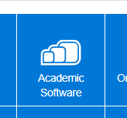Install Visual Studio **2019 Enterprise (no 2022)** from **Academic Software**.
  + Go to Chamilo > Homepage
  + Click on the tile Academic Software
  + Login
  + Put 'Visual Studio' in the search bar at the top

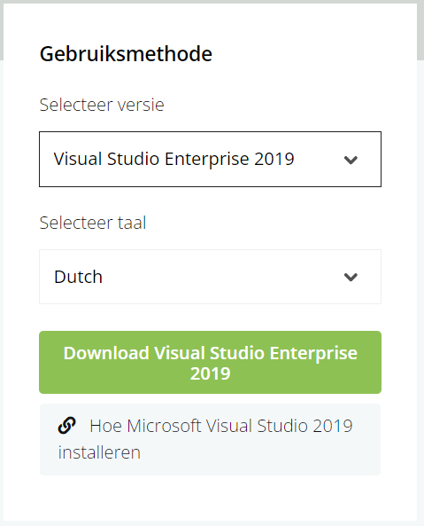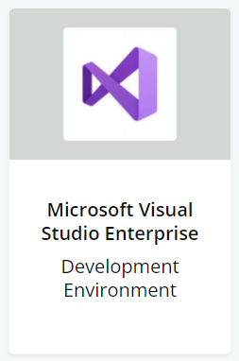

* + Click on Microsoft Visual Studio Enterprise
  + Choose the correct version at the right side of the screen
  + During the installation, Select SQL Server Data Tools under Data storage and processing in the list of workloads.

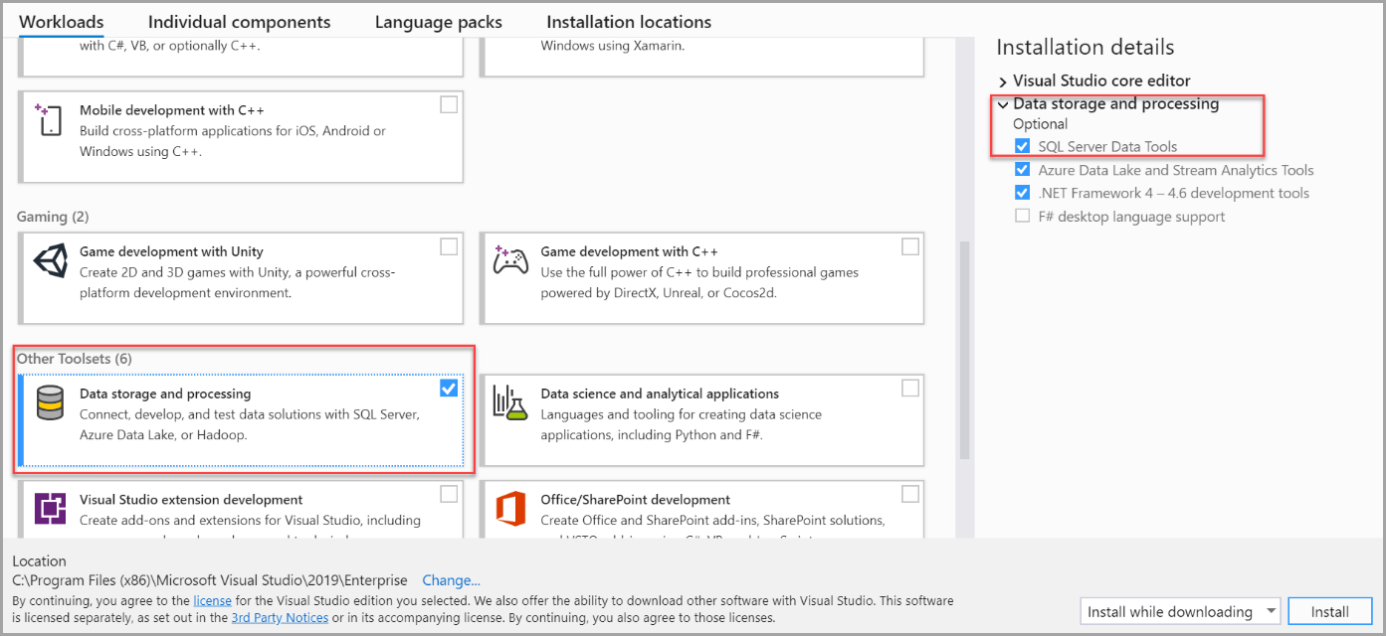

* Download and install SQL Server Integration Services from https://marketplace.visualstudio.com/items?itemName=SSIS.SqlServerIntegrationServicesProjects

**AdventureWorks**

1. Download AdventureWorks (e.g. AdventureWorks2019.bak for SQL Server 2019 or AdventureWorks2017.bak for SQL Server 2017) from <https://github.com/Microsoft/sql-server-samples/releases/tag/adventureworks>

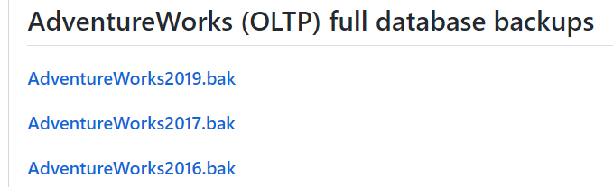

1. Put the .bak file directly on your C – drive (so you will be able to find it easily, afterwards you can remove the .bak file).
2. Open SQL Server Management Studio
3. Restore the OLTP database
   * Right click on Databases in SQL Server Management Studio > choose Restore Database

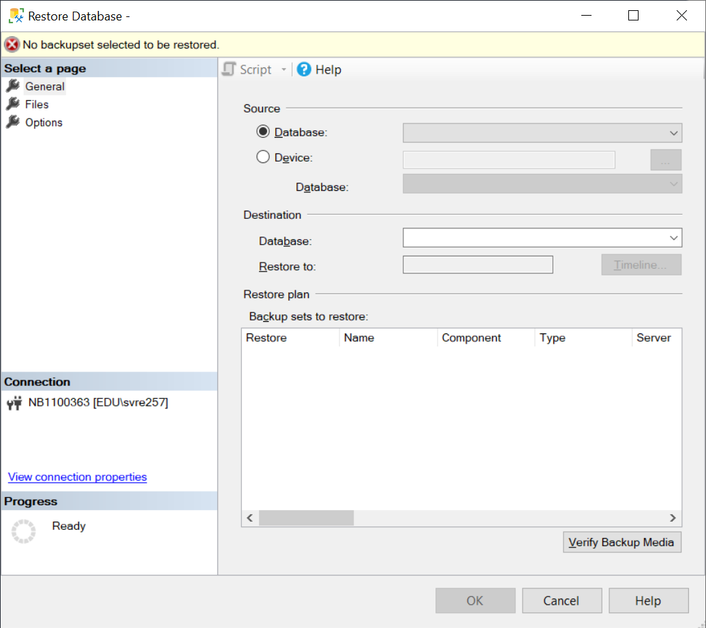

* + Choose Device > Click the button with …

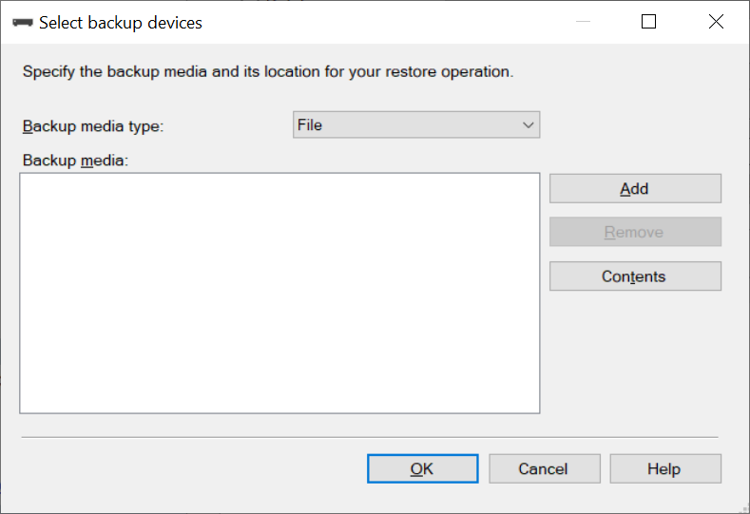

* + Click Add
  + Doubleclick on AdventureWorks.bak
  + Click OK x 2
  + The database should be restored succesfully

1. Take a look at the database. The tables we are going to use are
   * Production.Product
   * Sales.SalesOrderHeader
   * Sales.SalesOrderDetail
2. We are especially going to focus on product with ProductID = 776. Because this product was the first product ordered (SalesOrderDetailID = 1) in the first order (SalesOrderID = 43659)



**Create AdventureWorksDW**

1. In this tutorial we are going to create a small DW based on AdventureWorks
2. The star scheme looks like this

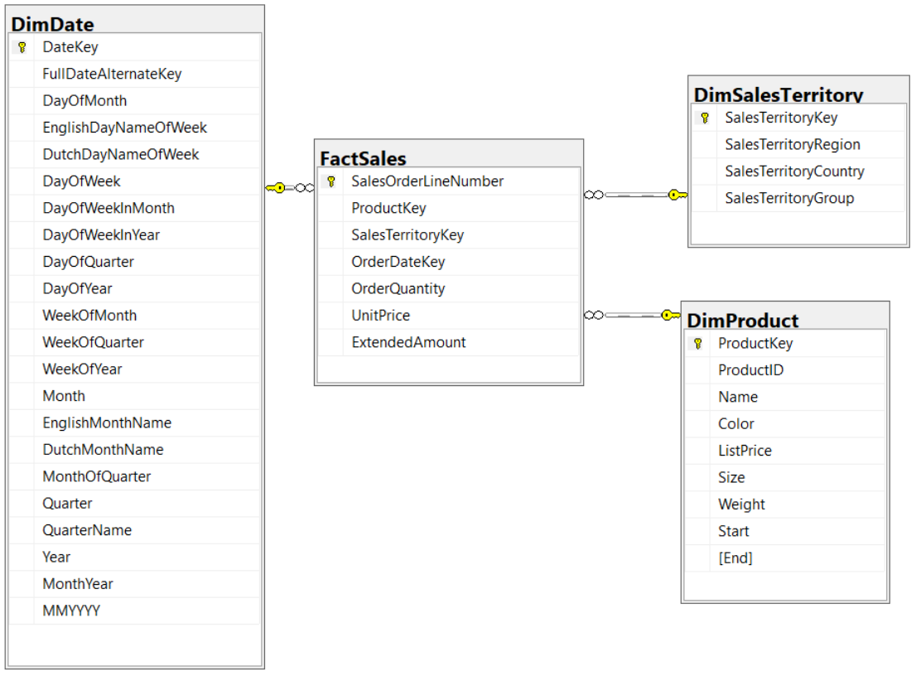

1. Create a new database AdventureWorksDW
   * Right click on Databases > Choose New Database
   * Database name = AdventureWorksDW
   * Click OK

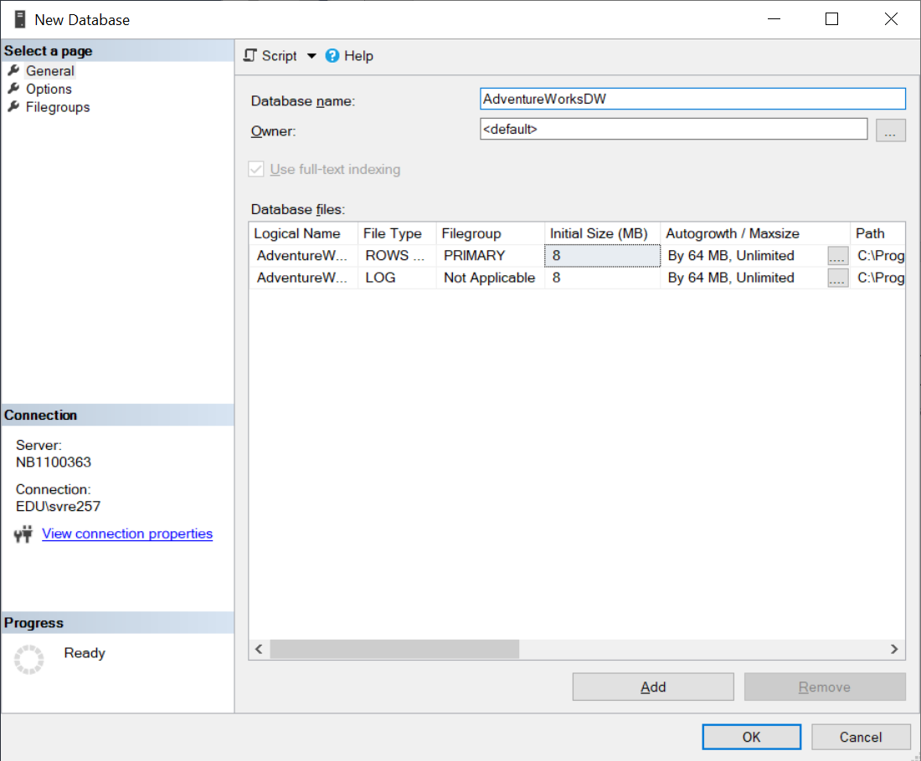

1. Download from Chamilo the file Documenten > Scripts > AdventureWorksDimDate.sql. In this file you find the code to create DimDate
2. Run this script to create DimDate. Make sure AdventureWorksDW is the active database
3. You can also use the GUI to create the tables Dimproduct, DimSalesTerritory and FactSales
4. Create a new table DimSalesTerritory
   * Right click on AdventureWorksDW > Tables > New … > Table
   * Right click in the leftmost column to set the primary key

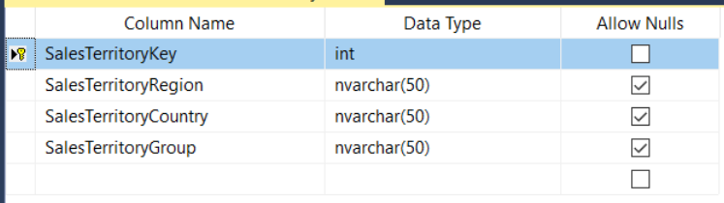

* + Save the table, Enter a name for the table: DimSalesTerritory

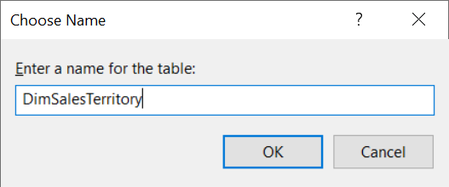

1. Create a new table DimProduct
   * Right click on AdventureWorksDW > Tables > New … > Table
   * Right click in the leftmost column to set the primary key

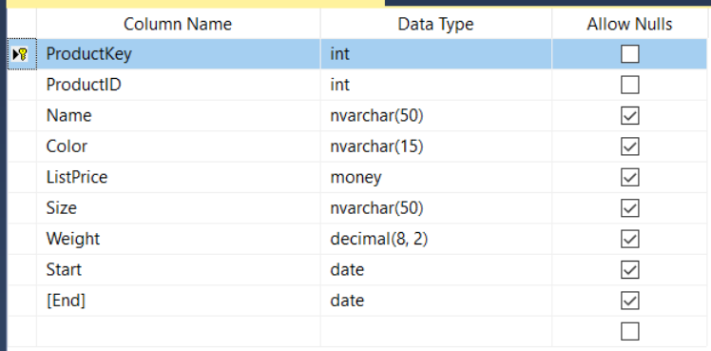

* + Specify **ProductKey** as an identity value with seed = 1 and increment = 1.

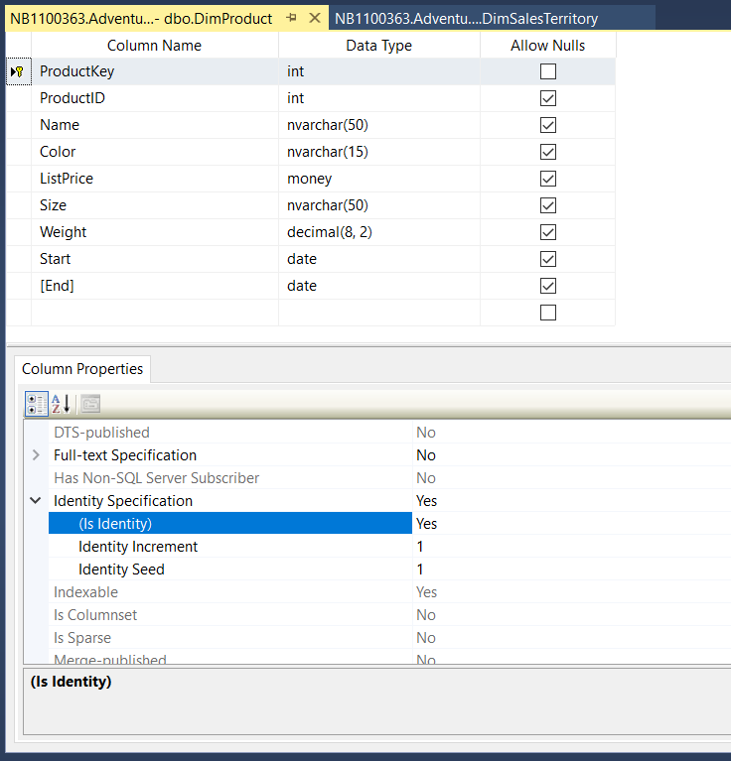

* + Save the table, Enter a name for the table: DimProduct

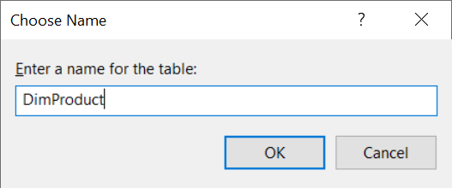

1. Create a new table FactSales
   * Right click on AdventureWorksDW > Tables > New … > Table
   * Right click in the leftmost column to set the primary key

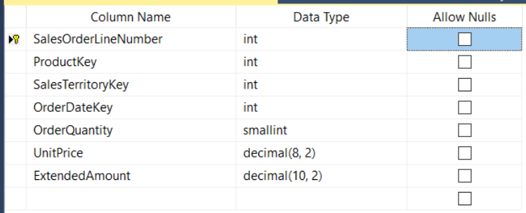

* + Save the table, Enter a name for the table: FactSales

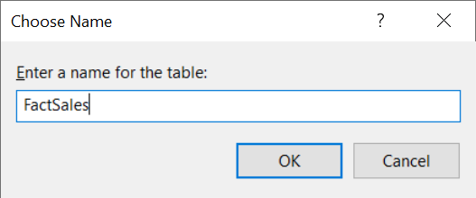

1. Add the Foreign Key constraints
   * ProductKey in FactSales is a foreign key to ProductKey in DimProduct
   * SalesTerritoryKey in FactSales is a foreign key to SalesTerritoryKey in DimSalesTerritory
   * OrderDateKey in FactSales is a foreign key to OrderDateKey in DimDate
   * Make sure that the 4 tables are saved and have an appropriate name
   * Open the design of FactSales if it's not still open
   * Right click in the white space and choose Relationships

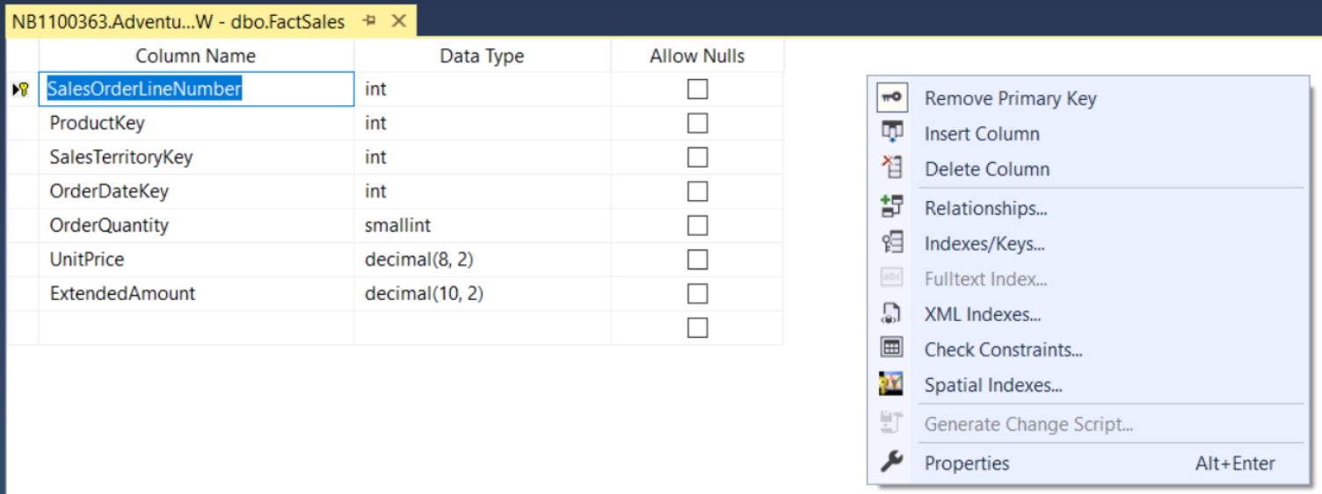

* + Click on the button Add at the bottom
  + Choose an appropriate name
  + Click on the … next to Tables and Columns Specification

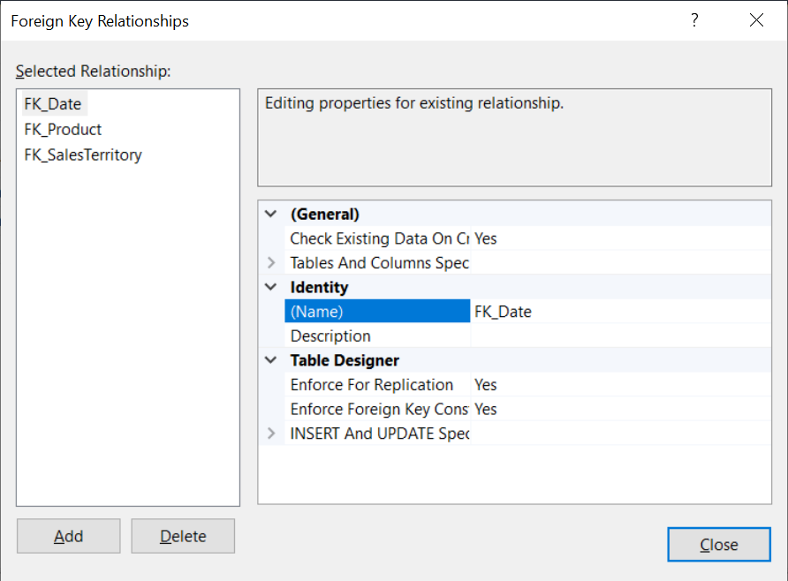

* + Set the Primary key table and the datafield at the left and the Foreign Key table and the datafield at the right

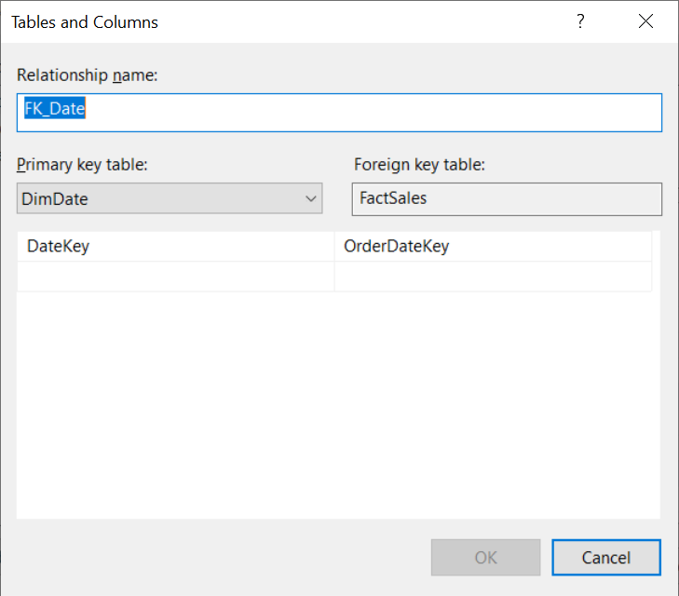

* + Click OK
  + Repeat the previous few steps for each of the 3 foreign keys that have to be set: FK_Date, FK_SalesTerritory and FK_Product

1. Make sure to retrieve the code to create each of the 4 tables (DimDate, DimProduct, DimSalesTerritory and FactSales). If you would have to delete and recreate a table, then you can use this script instead of having to redo everything by hand.
   * Right click on a table > Script Table as > CREATE TO > New Query Editor Window

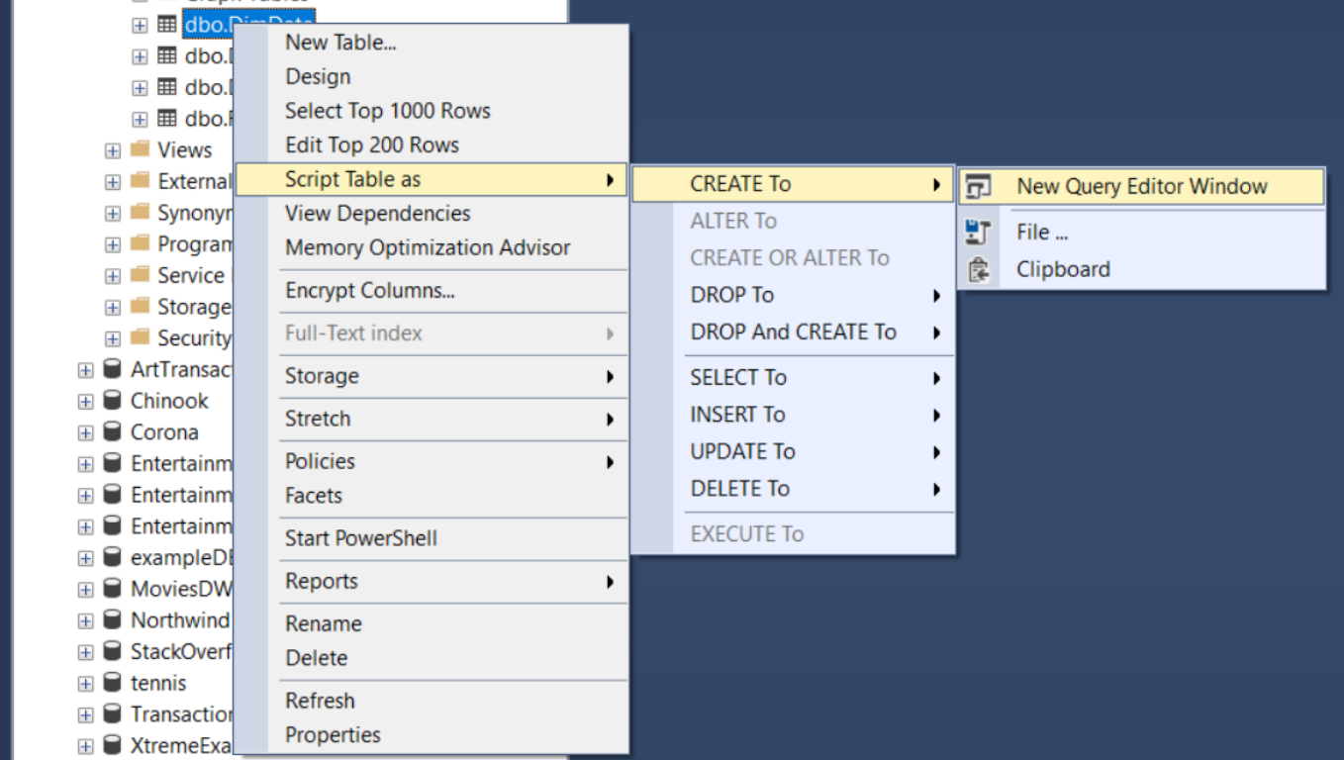

1. Make sure the tables in the DWH look OK before you continue.

**Using SSIS as ETL tool**

1. Imagine you want to copy every Friday night the new data from last week from the OLTP database to the DWH. Of course, you don't want to do this manually. So we are going to use a tool to copy new data from the OLTP database to the DWH.  
   We also need to be able to fill the DWH the first time with the correct data.
2. Start Visual Studio 2019
3. Click on Create a new Project

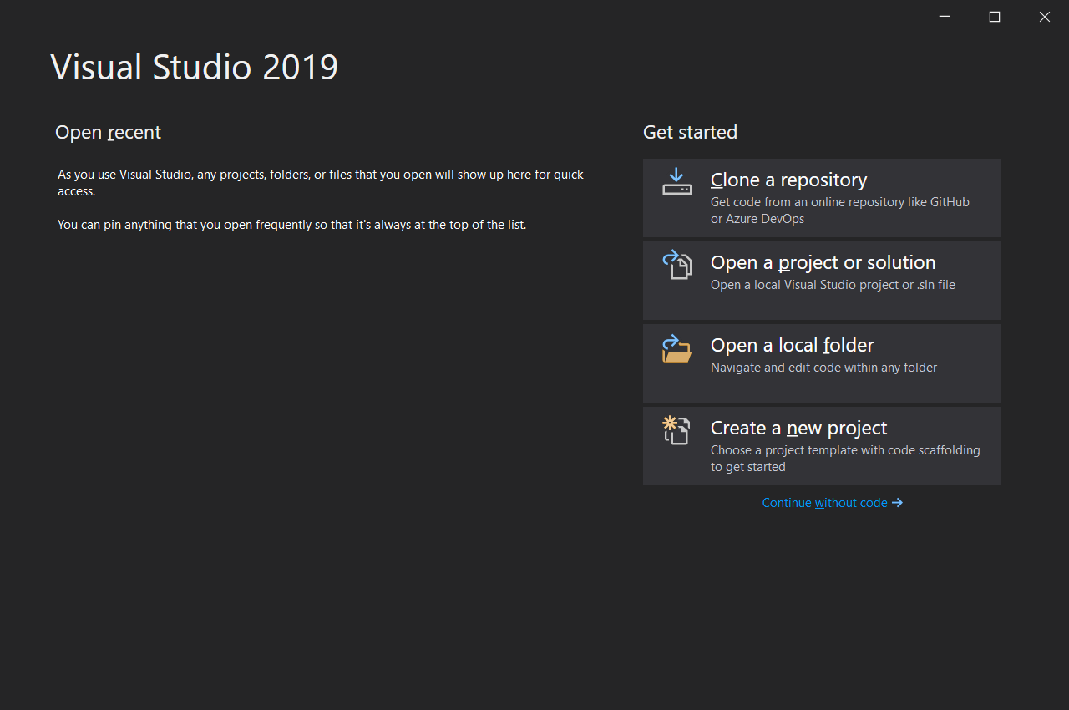

1. Type integration
2. Click on Integration Services Project

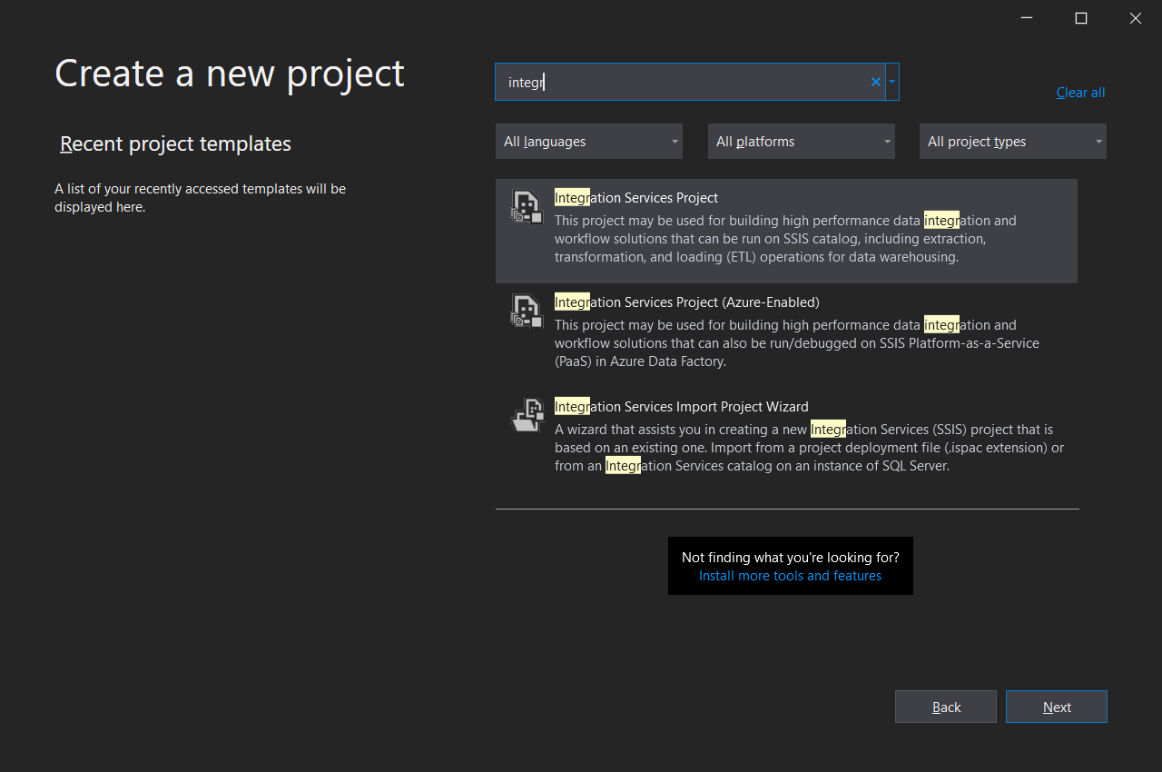

1. Project Name = AdventureWorksProject + Click on Create

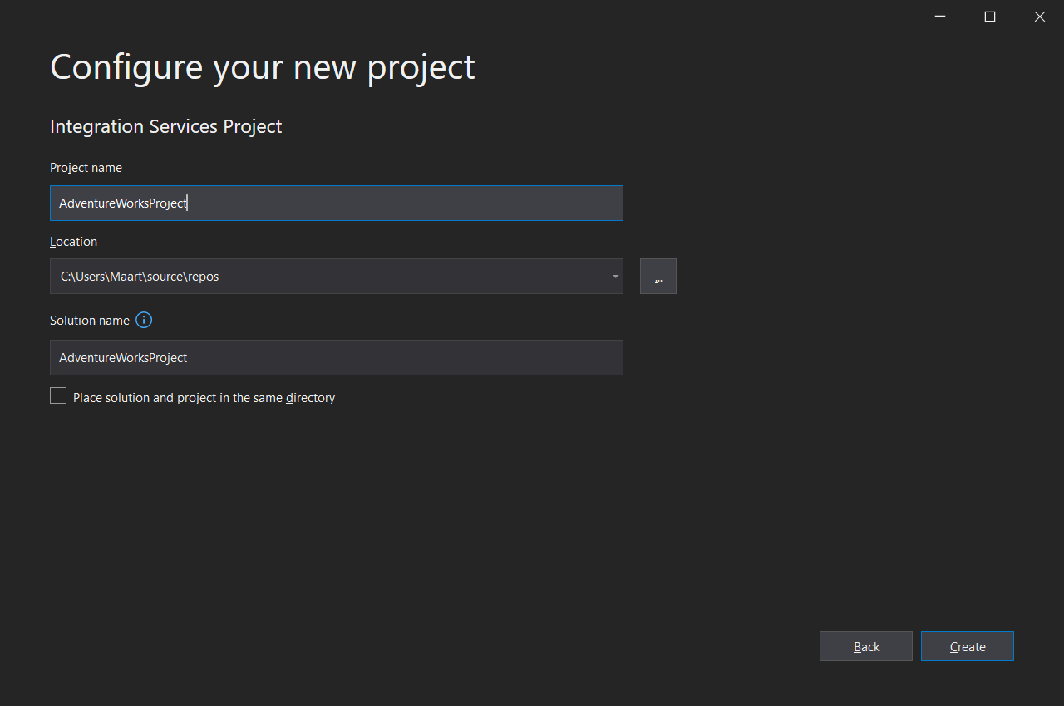

1. In the Solution Explorer (at the right side) rename package.dtsx to FillDW.dtsx

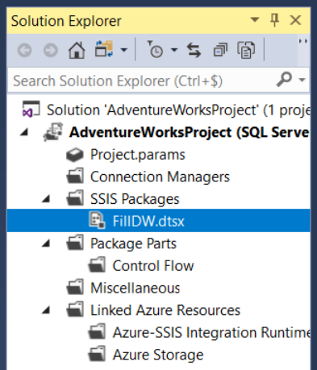

**Fill DimDate 🡪 Fill dimension using a script**

1. Use the OLTP Database to find out the minimum and maximum OrderDate in SalesOrderHeader
2. Download from Chamilo the file Documenten > Scripts > Fill_DimDate.sql. In this file you find the code to fill DimDate
3. Make sure you understand this script. This script is derived from <https://www.codeproject.com/Articles/647950/Create-and-Populate-Date-Dimension-for-Data-Wareho> and will be used to fill DimDate
4. Because we will be using this script to fill DimDate, the process will be slightly different from filling the 2 other dimensions, i.e. DimSalesTerritory and DimProduct
5. In Visual Studio 2017 SSDT, drag and drop 'Execute SQL Task' from the SSIS Toolbox (at the left) to the Control Flow area

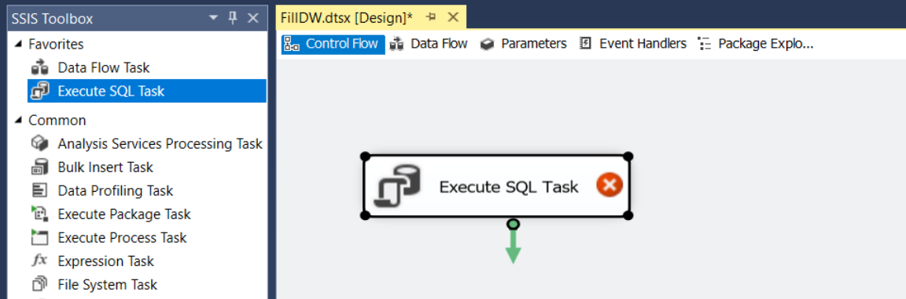

1. We will use this SQL Task to delete all records from DimDate before each transfer.
2. Right click on the 'Execute SQL Task' and choose Edit… to configure the 'Empty DimDate' task

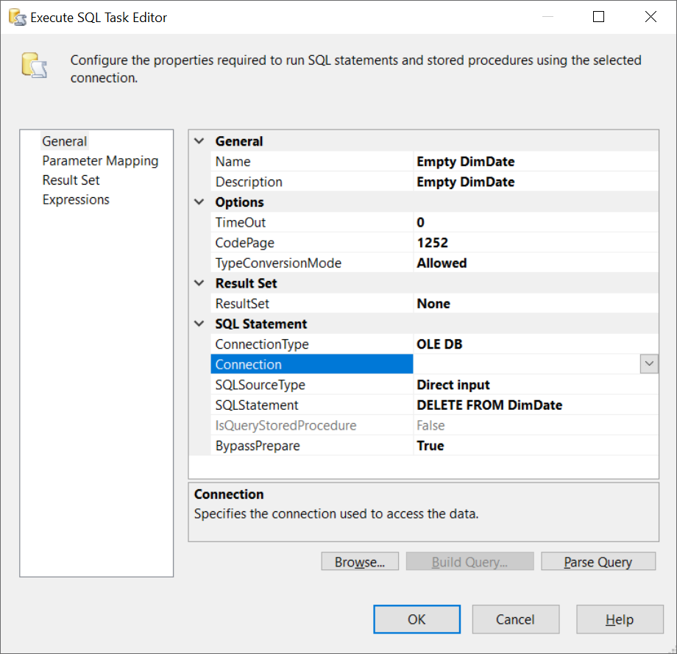

1. The Connection is still missing and should be configured
   * Click on the arrow next to Connection
   * Choose New connection
   * Click New…

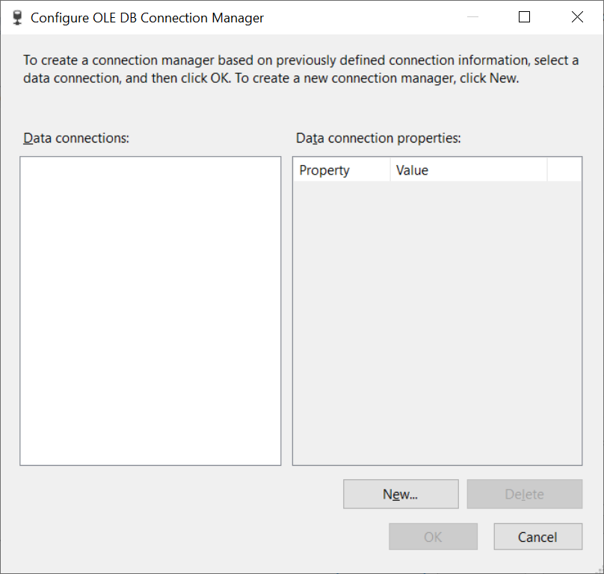

* + Fill in the Server name. You don't have to use the dropdownlist, just fill in the Server name. You can find the Server name in Microsoft SQL Server Management Studio

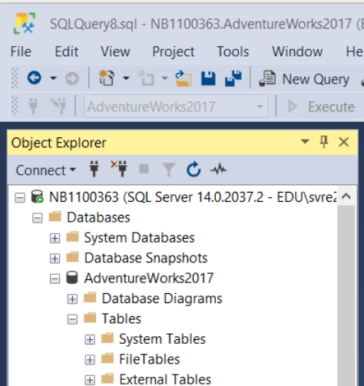

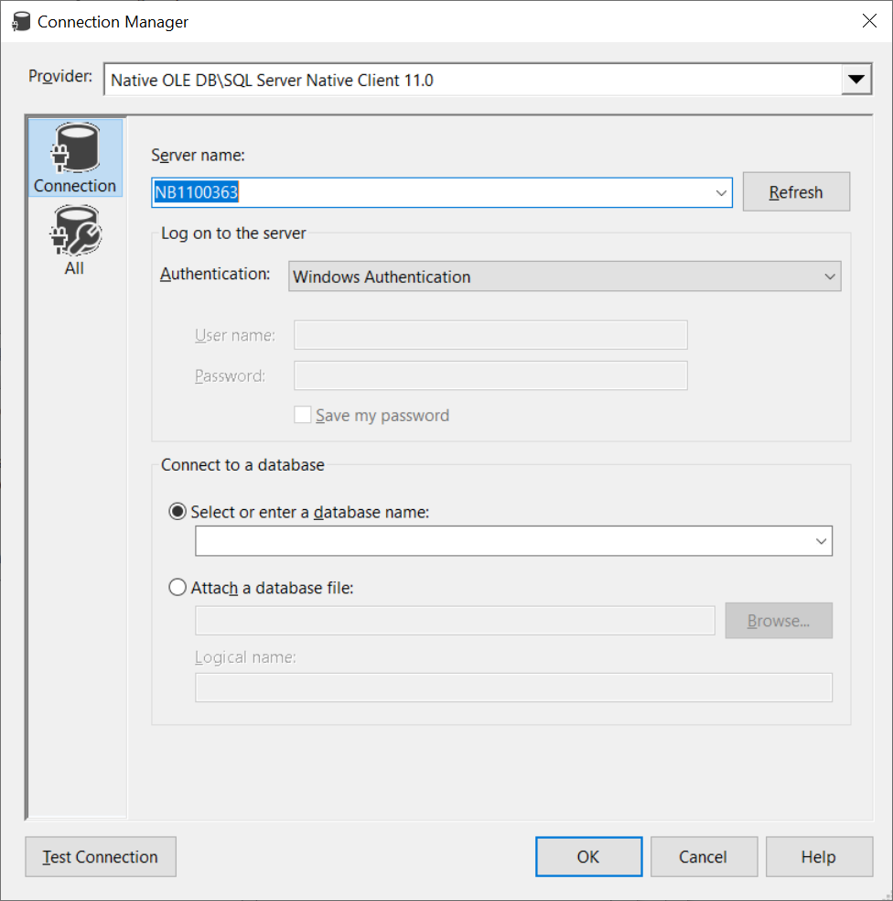

* + Select the correct database in the dropdownlist 'Select or enter a database name'. Because this Connection will be used to connect to AdventureWorksDW, this is of course the name of the database we select.
  + Click OK

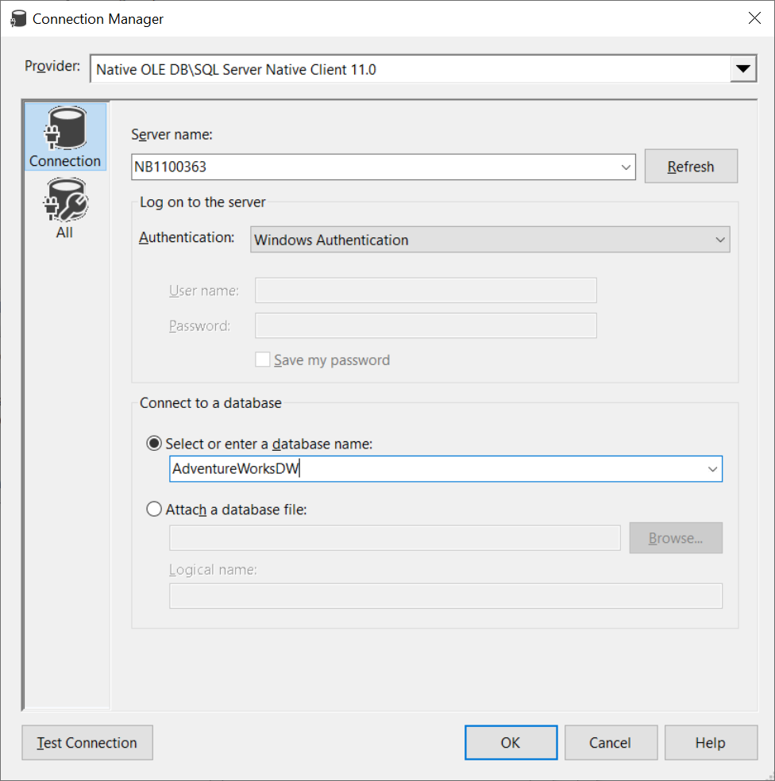

* + Click OK

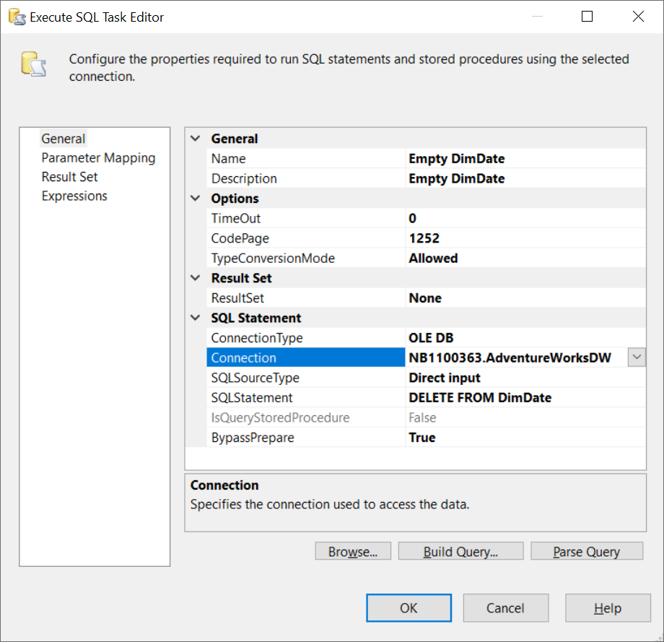

* + Click OK

1. In Visual Studio 2017 SSDT, drag and drop 'Execute SQL Task' from the SSIS Toolbox (at the left) to the Control Flow area
2. We will use this SQL Task to run the script Fill_DimDate to fill DimDate.
3. Connect both tasks

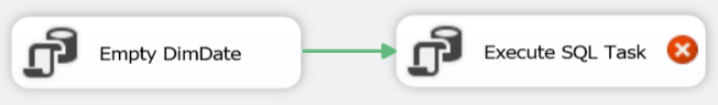

1. Right click on the 'Execute SQL Task' and choose Edit… to configure the 'Fill DimDate' task

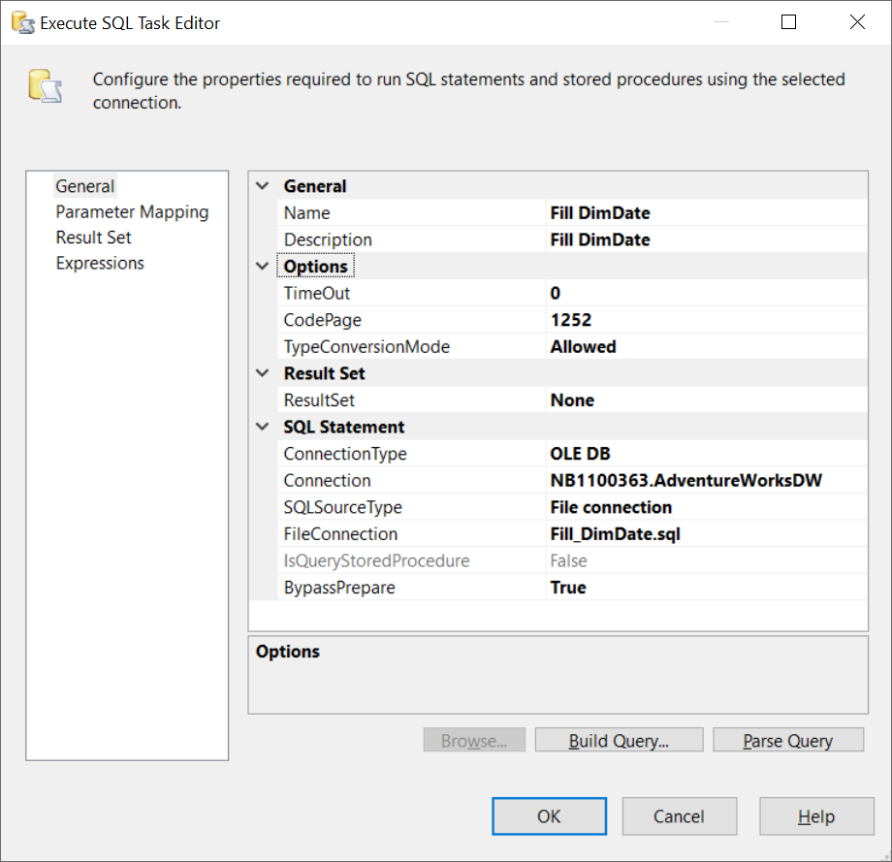

1. The FileConnection is still missing and should be configured
   * Click on the arrow next to FileConnection
   * Choose New connection

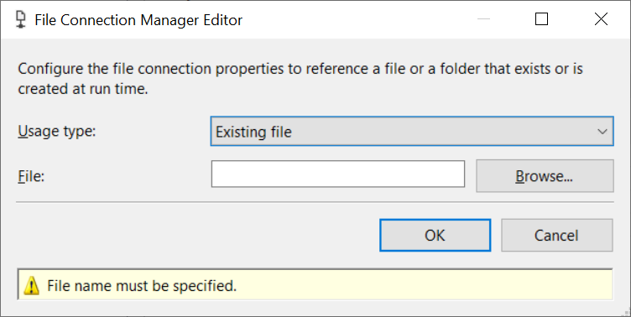

* + Click Browse… and select Fill_DimDate.sql
  + Click OK

1. Before you continue, check if the current flow is already working by clicking on Start 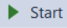

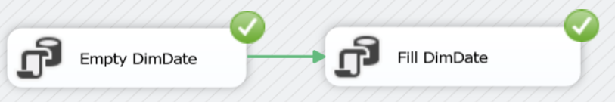

1. Go to Microsoft SQL Server Management Studio and check if AdventureWorksDW > DimDate contains the correct data

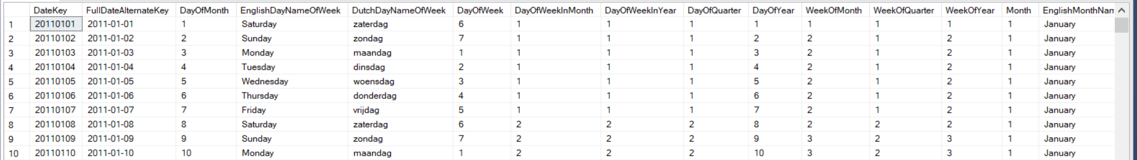

**Fill DimSalesTerritory 🡪 Fill dimension using a view**

1. First create this view in the **OLTP database AdventureWorks.** We will use this view to fill **DimSalesTerritory**

CREATE VIEW VWSalesTerritory AS

SELECT t.TerritoryID SalesTerritoryKey, t.Name SalesTerritoryRegion, c.Name SalesTerritoryCountry,t.[Group] SalesTerritoryGroup

FROM sales.SalesTerritory t join person.CountryRegion c

ON t.CountryRegionCode=c.CountryRegionCode;

1. In Visual Studio 2017 SSDT, drag and drop 'Execute SQL Task' from the SSIS Toolbox (at the left) to the Control Flow area.  
   Connect with the previous tasks

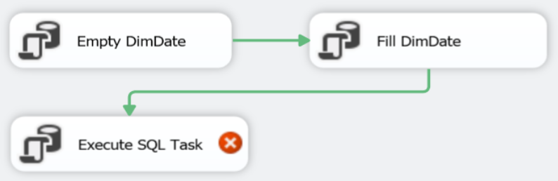

1. We will use this SQL Task to delete all records from DimSalesTerritory before each transfer.
2. Right click on the 'Execute SQL Task' and choose Edit… to configure the 'Empty DimSalesTerritory' task

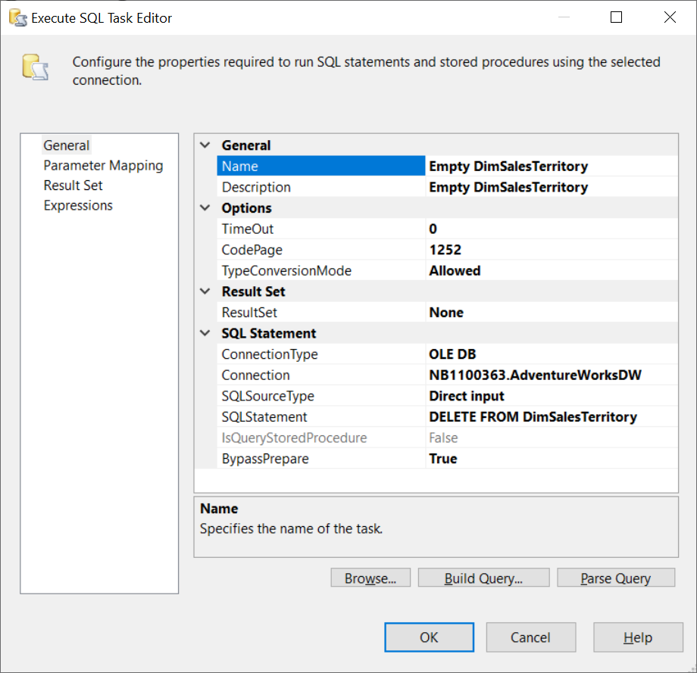

1. To 'refill' DimSalesTerritory drag and drop 'Data Flow Task' from the SSIS Toolbox (at the left) to the Control Flow area.   
   Connect with the previous tasks.

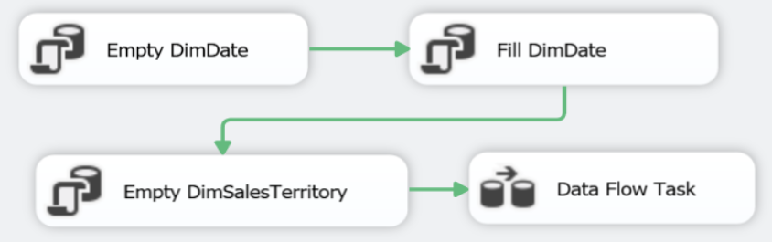

1. Right click on Data Flow Task and choose Rename, to rename the 'Data Flow Task' to 'Fill DimSalesTerritory'

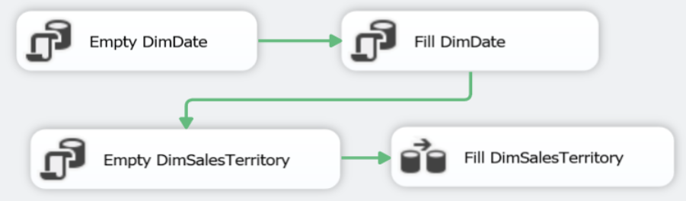

1. Right click on 'Fill DimSalesTerritory' and choose Edit… to configure the Fill DimSalesTerritory' task.
2. Notice that you are now in the 'Data Flow' area
3. Drag and drop 'Source Assistant' from the SSIS Toolbox (at the left) to the Data Flow area

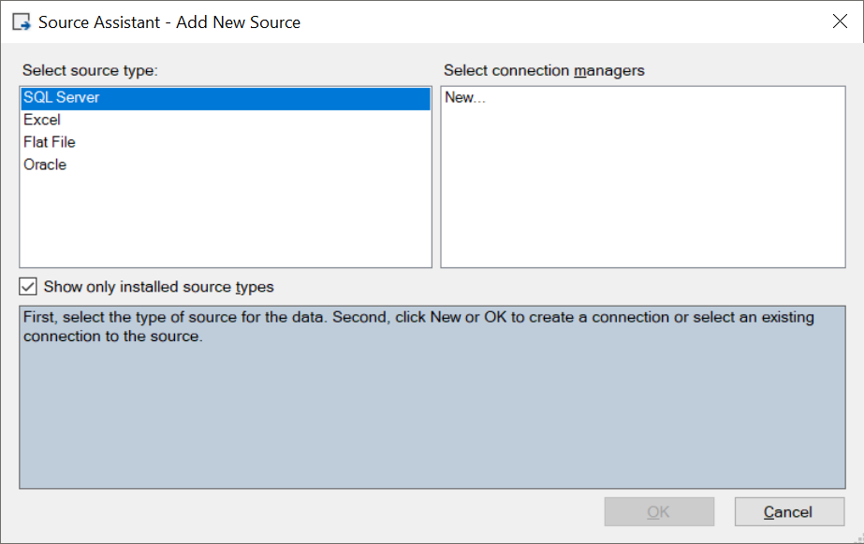

1. Select New… in the Select connection managers at the right side. Click OK.
2. We need to connect to the OLTP database AdventureWorks and we don't have a connection to this database yet, that's why we need a new connection. We do have a connection with the DWH AdventureWorksDW, but that's another database.
3. Enter the Server name, the same as you did to establish the connection with the DWH
4. Choose the correct database in the dropdownlist Initial catalog

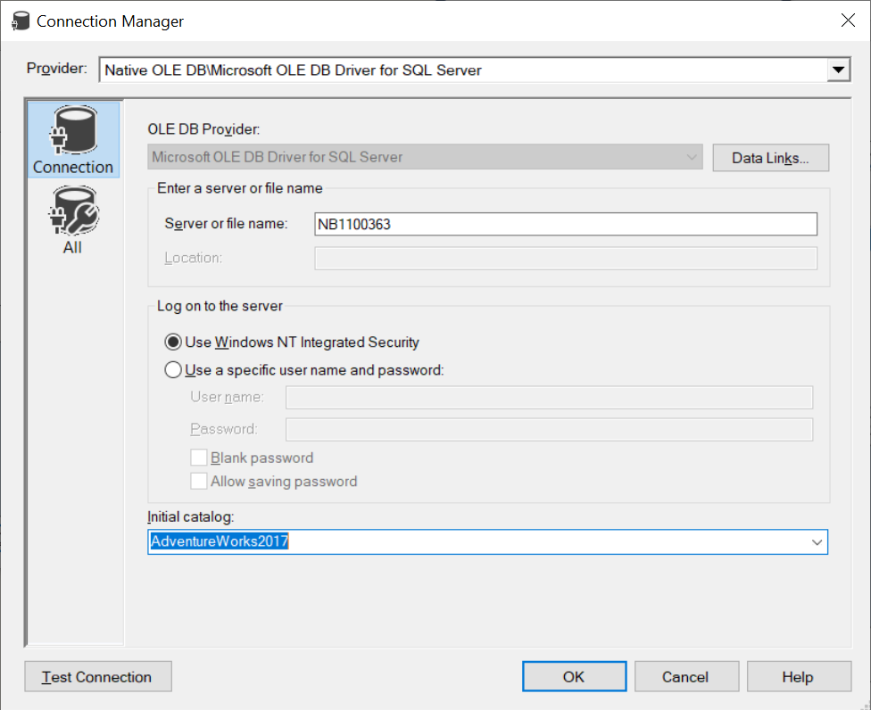

1. Click OK

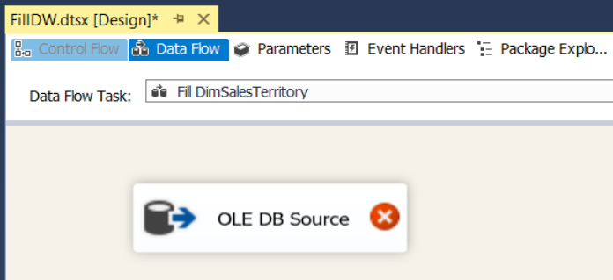

1. Drag and drop 'Destination Assistant' from the SSIS Toolbox (at the left) to the Data Flow area
2. Select the connection manager at the right side

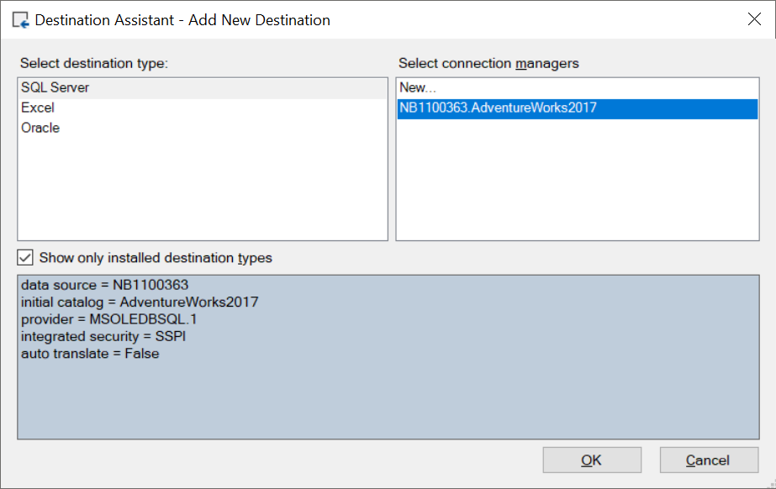

1. Click OK
2. Connect the Source Assistant and the Destination Assistant

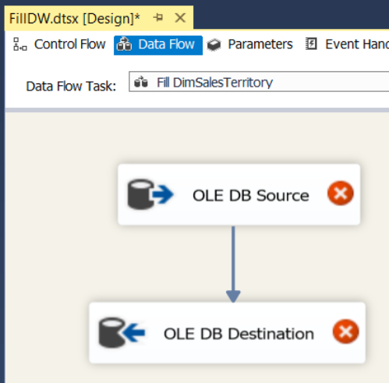

1. Right click on 'OLE DB Source' and choose Edit… to configure the source.
2. Choose VWSalesTerritory as the correct data source
3. Click OK

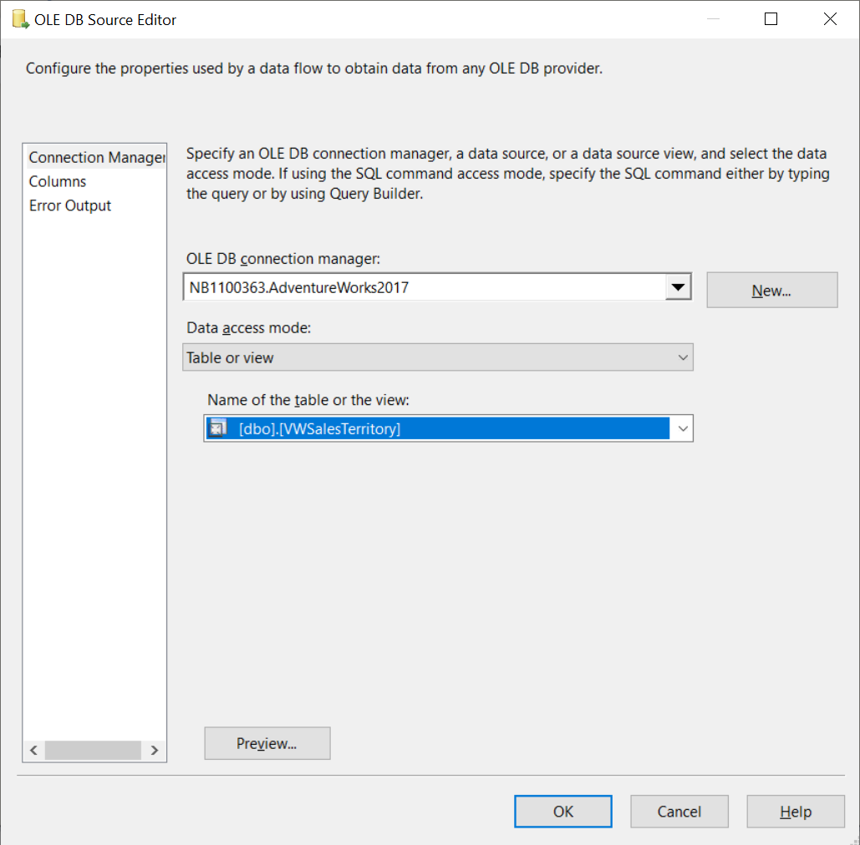

1. Right click on 'OLE DB Destination' and choose Edit… to configure the destination.
2. Choose the appropriate values for OLE DB connection manager (= the connection manager for the DWH!!) and for the table

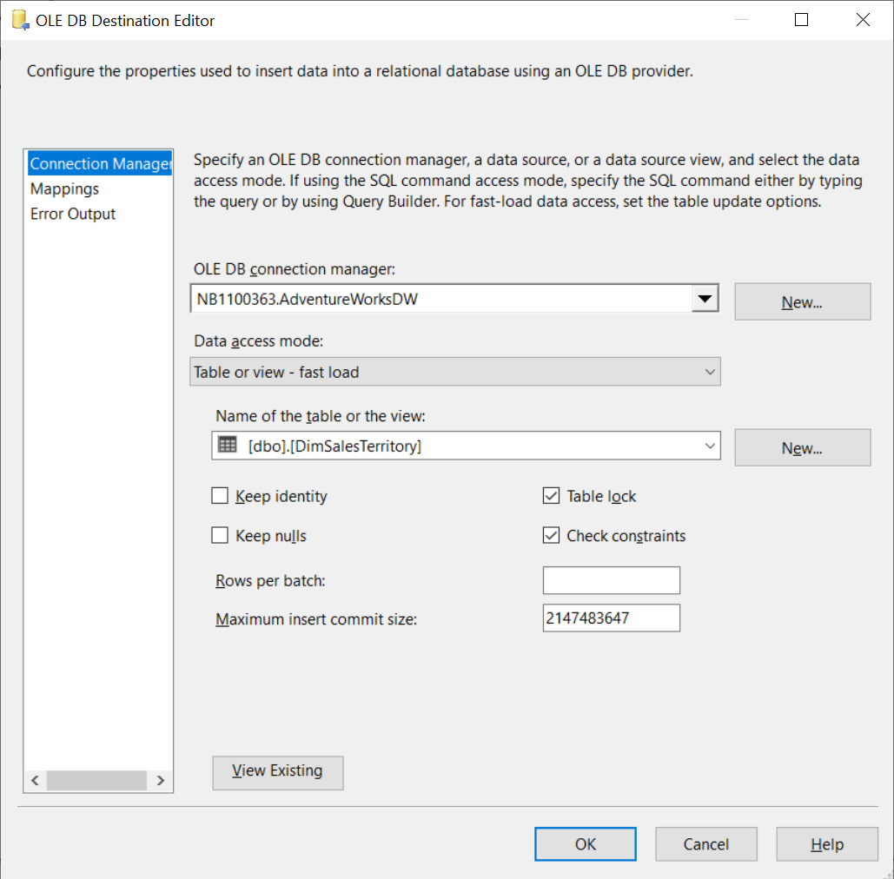

1. Click on Mappings on the left to check if the Mappings between the view VWSalesTerritory in AdventureWorks and the table DimSalesTerritory are correct
2. Click OK

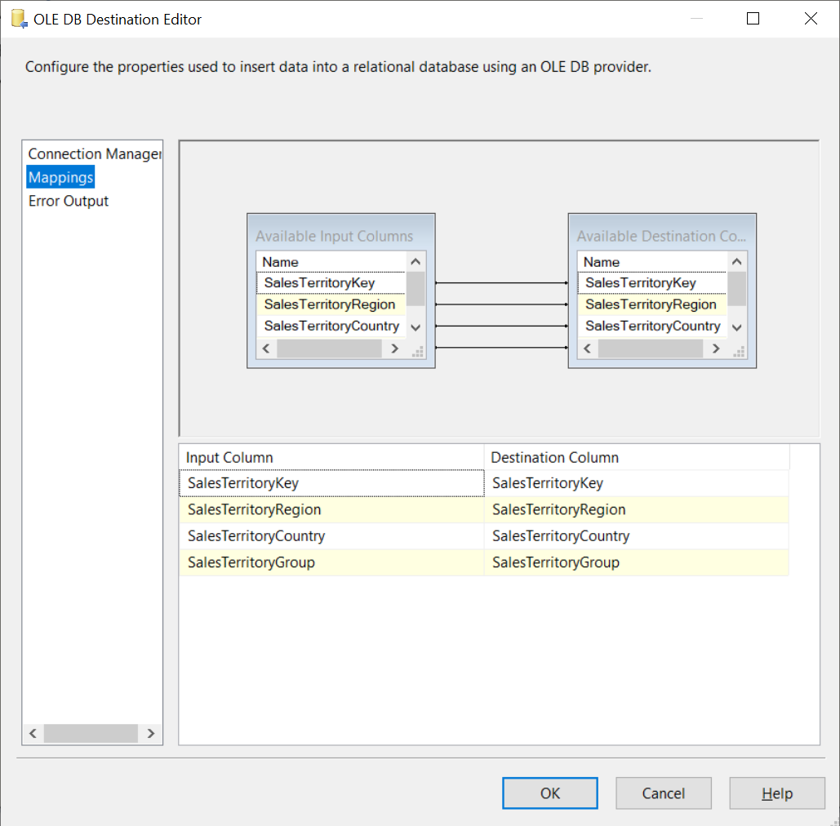

1. Go back to the Control Flow area and run the provisional pipeline

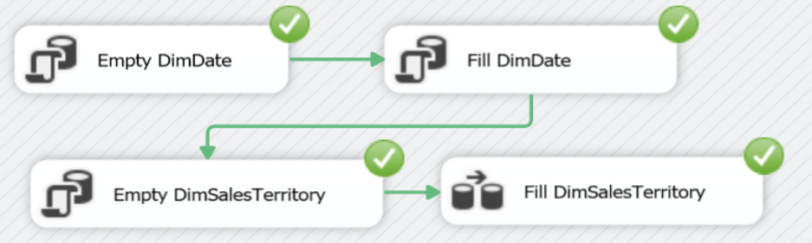

1. Go to Microsoft SQL Server Management Studio and check if AdventureWorksDW > DimDate and AdventureWorksDW > DimSalesTerritory contain the correct data

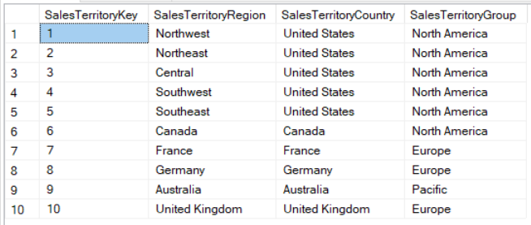

**Fill DimProduct 🡪 Slowly changing dimension**

1. In Visual Studio 2017 SSDT, drag and drop 'Data Flow Task' from the SSIS Toolbox (at the left) to the Control Flow area.
2. Right click on Data Flow Task and choose Rename, to rename the 'Data Flow Task' to 'Fill DimProduct'.
3. Connect to the previous tasks

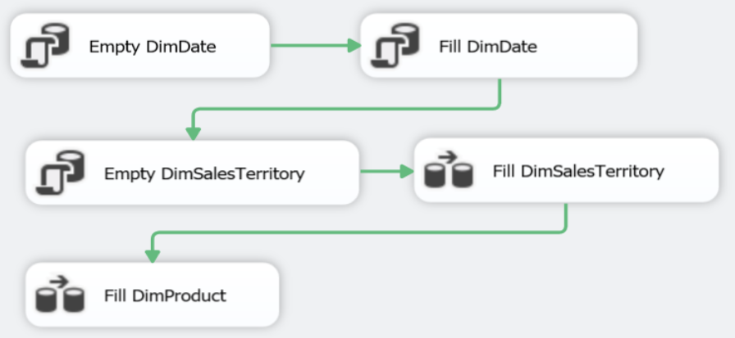

1. We don't need a DELETE task since we want to build product history!
2. Right click on Fill DimProduct and choose Edit… to configure the 'Fill DimProduct' task
3. Notice that you are now in the 'Data Flow' area
4. Drag and drop 'OLE DB Source' and 'Slowly Changing Dimension' from the SSIS Toolbox (at the left) to the Data Flow area
5. Connect both

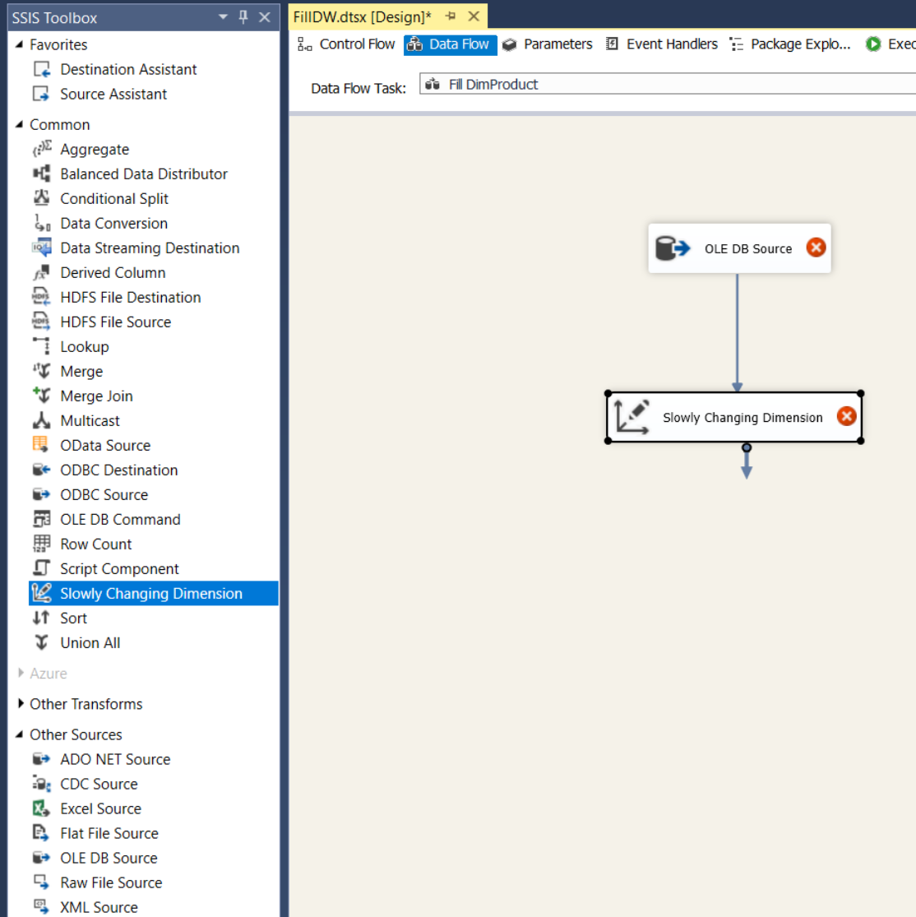

1. Right click on OLE DB Source and choose Edit… to specify the [Production].[Product] table from the OLTP database AdventureWorks as the OLE DB Source

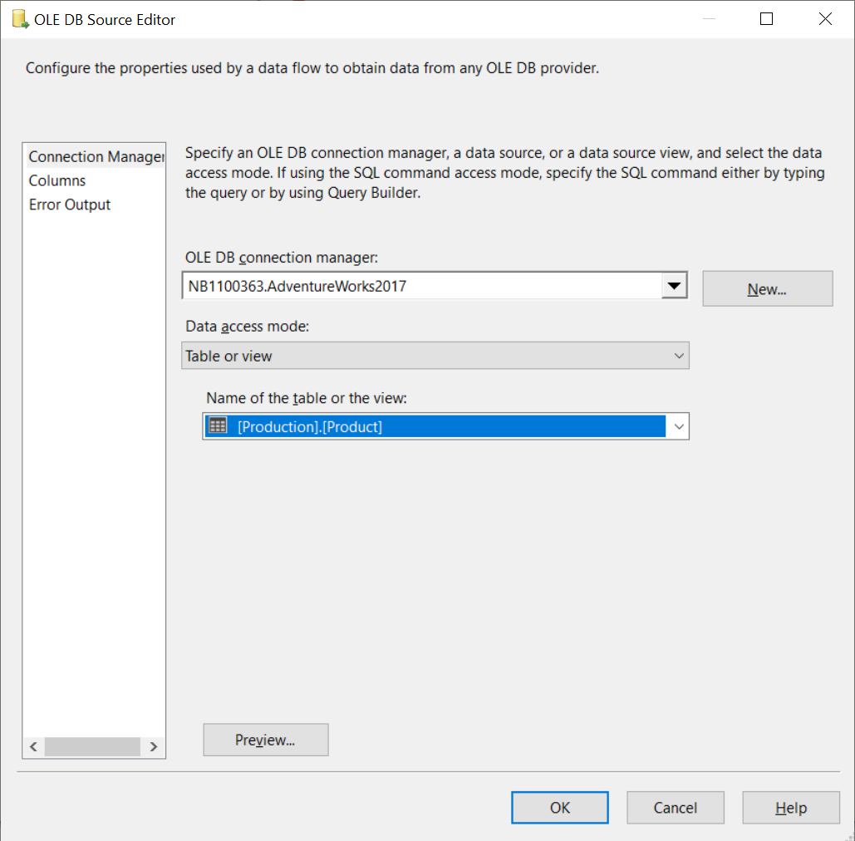

1. Click OK
2. Right click on Slowly Changing Dimension and choose Edit… to start the wizard for the Slowly Changing Dimenion task

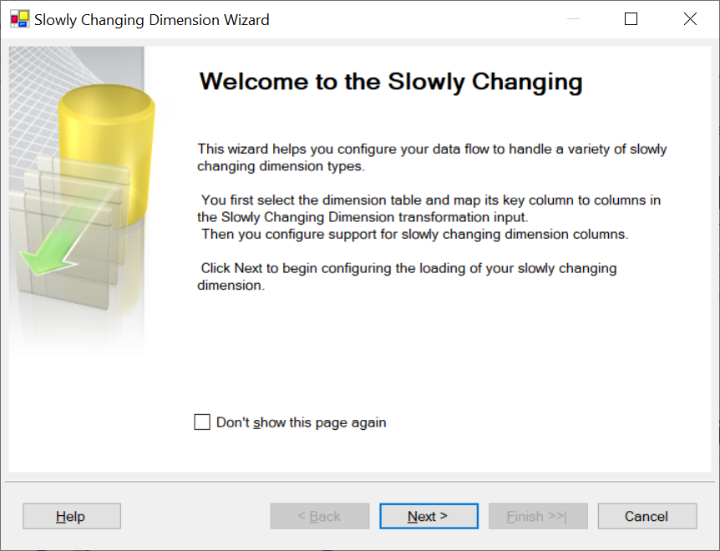

1. Click Next
2. Choose the appropriate values for OLE DB connection manager (= the connection manager for the DWH!!) and for the table  
   Change the Key Type next to ProductID to Business key

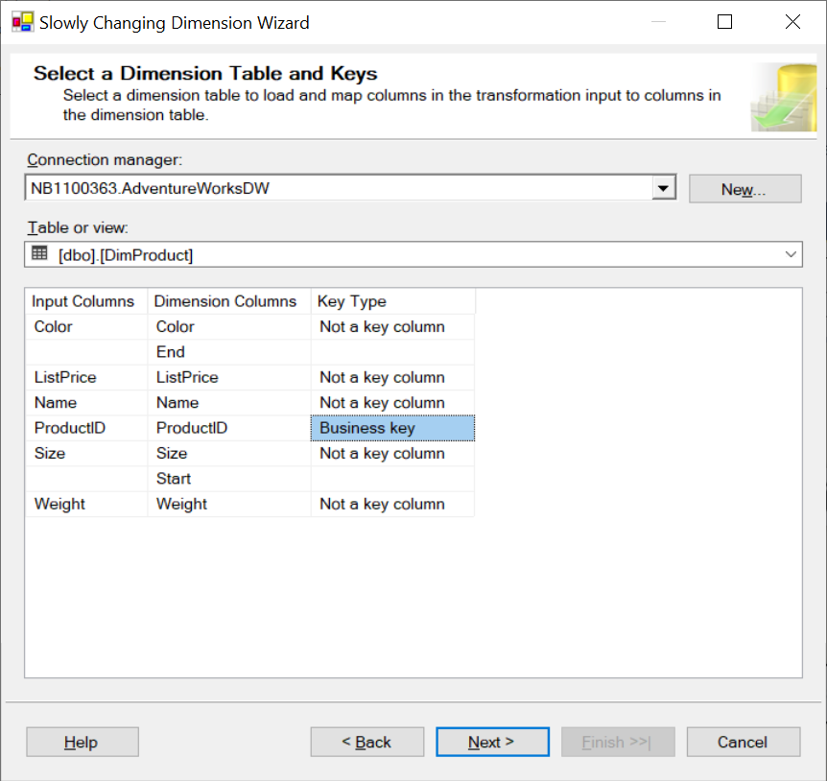

1. Click Next
2. Select a change type for slowly changing dimension columns

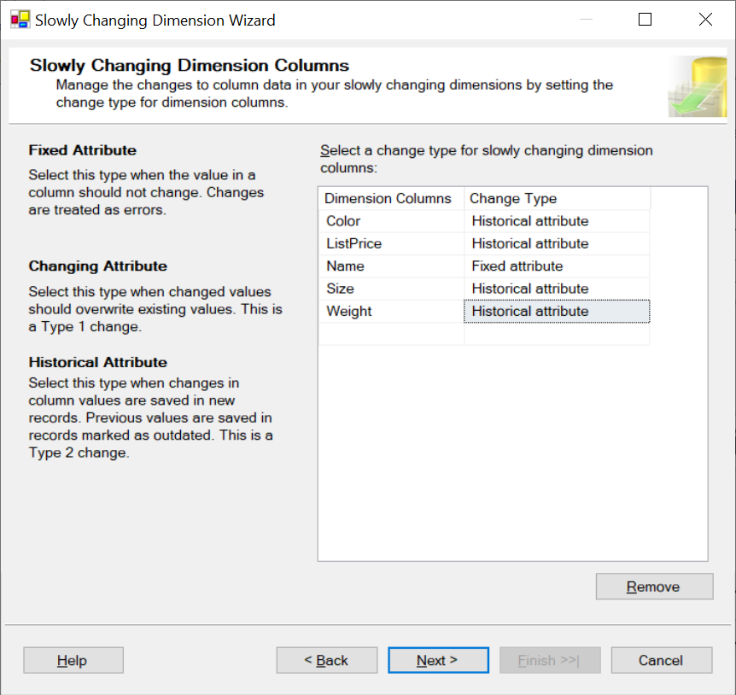

1. Click Next

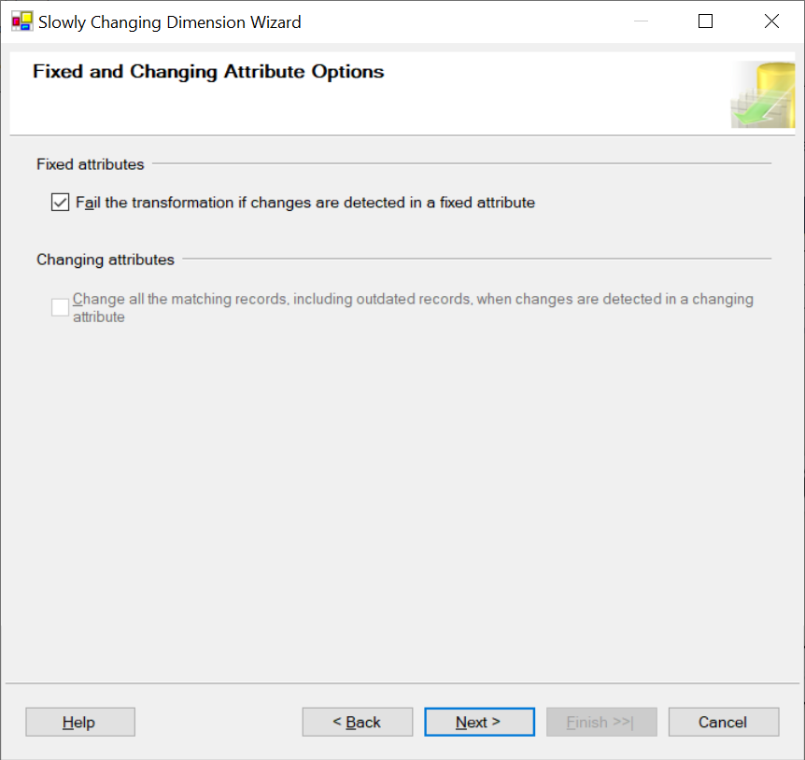

1. Click Next
2. Change the Variable to set data values

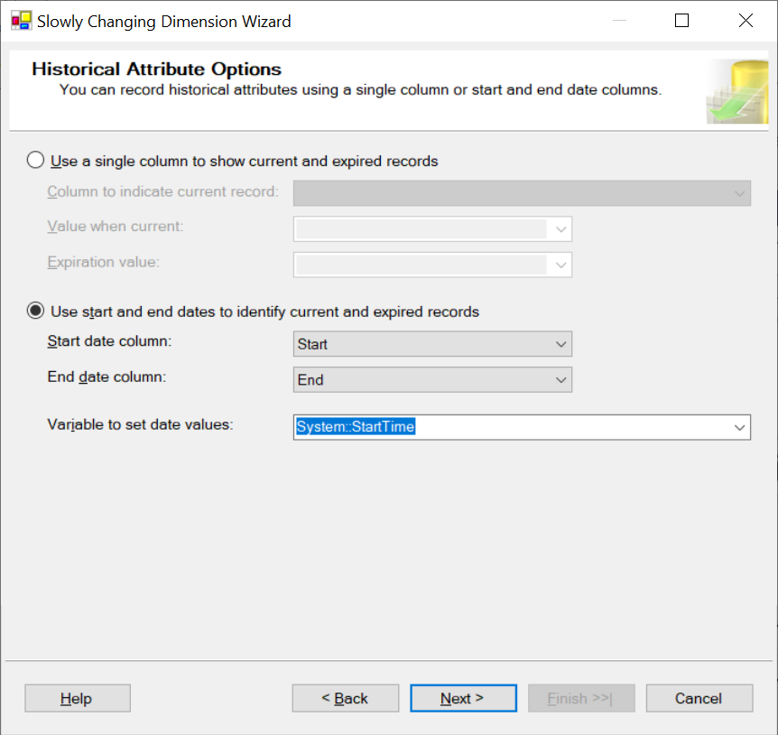

1. Click Next

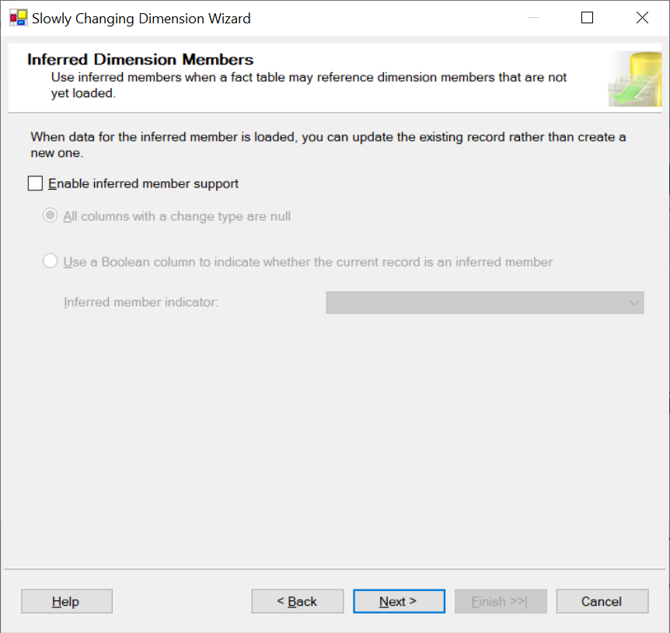

1. Click Next

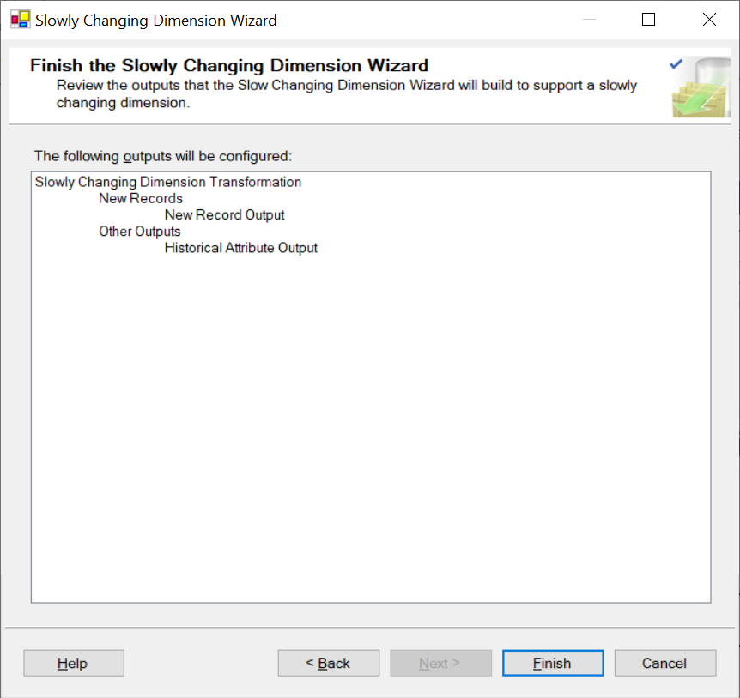

1. Click Finish

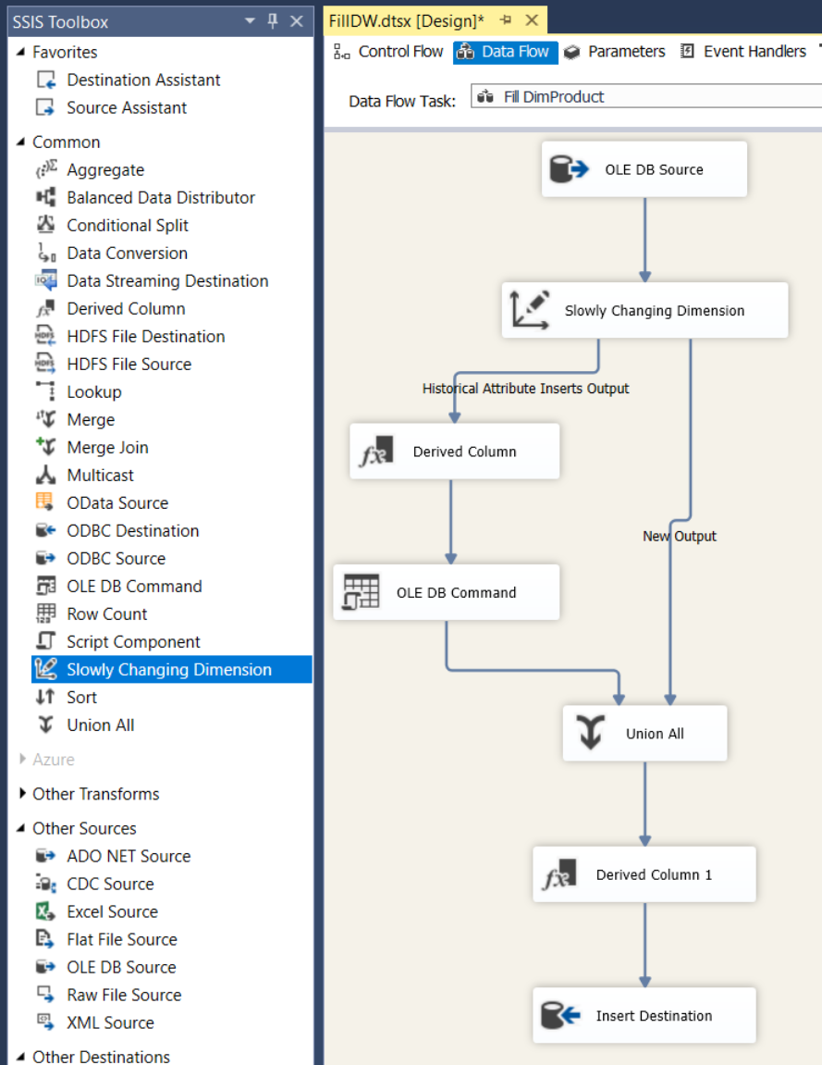

1. By default SSIS sets the End date equal to the new start date. It seems more appropriate to set the end date to yesterday (the day before the SSIS runs) and the new start date to today.
2. Right click on 'Derived Column' and choose Edit… to change the Expression field as follows:

DATEADD("day",-1,(DT_DBDATE)(@[System::StartTime]))

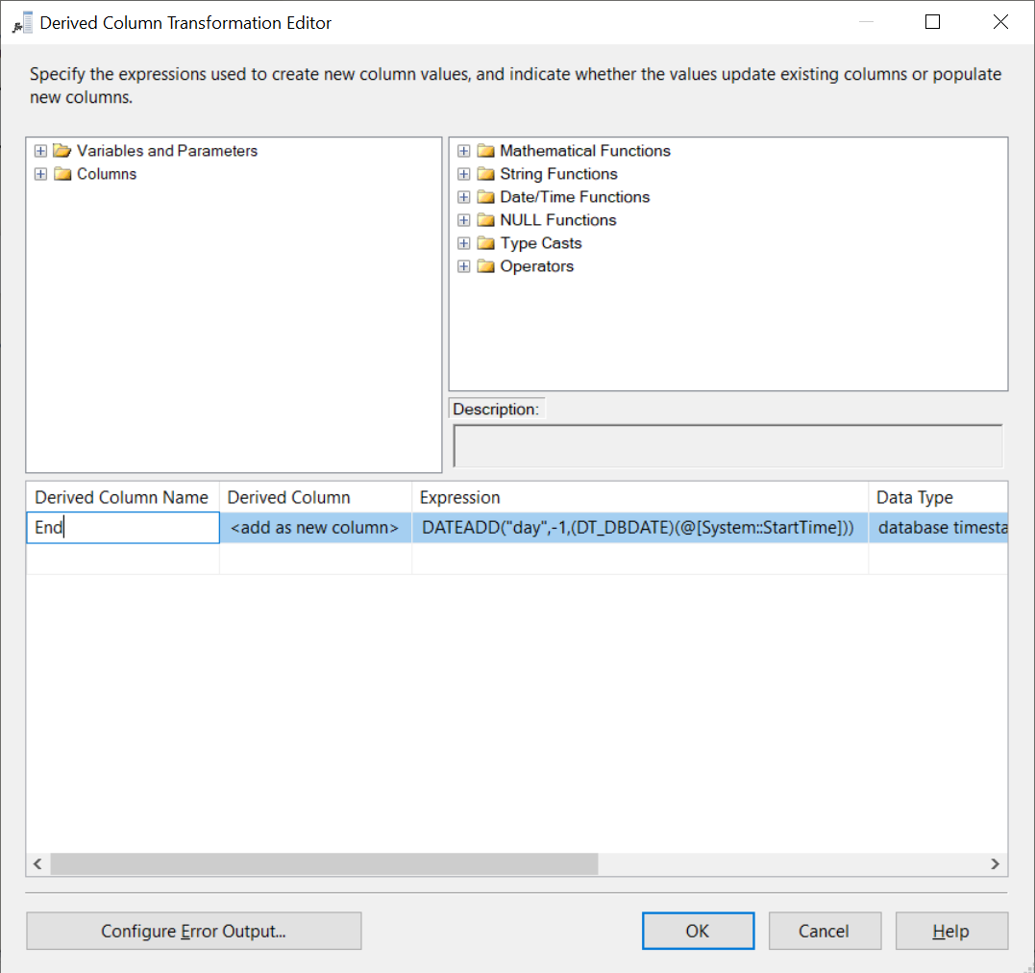

1. Click OK
2. Go back to the Control Flow area and run the provisional pipeline

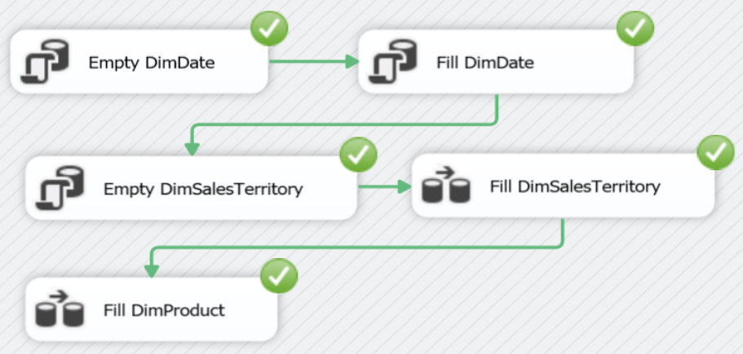

1. Go to Microsoft SQL Server Management Studio and check if AdventureWorksDW > DimDate and AdventureWorksDW > DimSalesTerritory and AdventureWorksDW > DimProduct contain the correct data
2. DimProduct is filled but for Start = today.

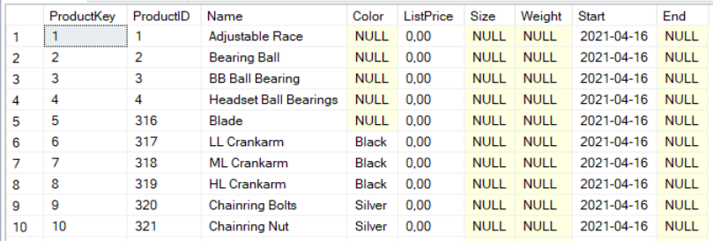

1. From a business point of view this is essentially wrong. Current product data is valid since the start of the company (since we have no history yet). So execute:

UPDATE DimProduct set Start =

(SELECT MIN(orderdate) from AdventureWorks2019.Sales.SalesOrderHeader);

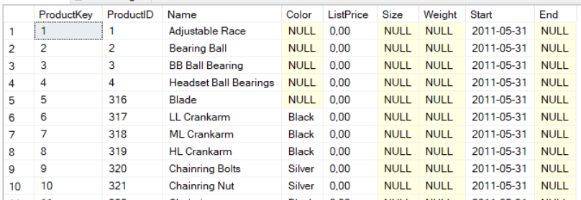

1. Check what happens if e.g. the color of a product is updated and you rerun the package.  
   (We choose product with productid = 776 deliberately as will become clear in a few steps.)
   * In the OLTP database  
     UPDATE production.product SET color = 'Blue' WHERE productid = 776;
   * Rerun the package
   * In the DWH  
     SELECT * FROM DimProduct WHERE productid = 776;  
     🡪 There are now two lines of this product.



**Fill FactSales 🡪 fill fact table**

1. We will use the following SQL statement to fill the table FactSales repeatedly

INSERT INTO FactSales(SalesOrderLineNumber, ProductKey, SalesTerritoryKey,

OrderDateKey, OrderQuantity, UnitPrice, ExtendedAmount)

SELECT d.SalesOrderDetailID, p.ProductKey, h.TerritoryID, CAST(FORMAT(h.OrderDate,'yyyyMMdd') as int), d.OrderQty, d.UnitPrice,

d.OrderQty * d.UnitPrice

from AdventureWorks2019.Sales.SalesOrderHeader h join

AdventureWorks2019.Sales.SalesOrderDetail d on h.SalesOrderID = d.SalesOrderID

join DimProduct p on d.ProductID = p.ProductID

WHERE

/* Slowly Changing Dimension dimproduct */

h.OrderDate >= p.start and (p.[end] is null or h.orderdate <= p.[end])

AND

/* only add new lines + make sure it runs from an empty FactSales table */

**d.SalesOrderDetailID > (SELECT ISNULL(MAX(SalesOrderLineNumber),0) from FactSales)**

1. To understand why this SQL statement is 'doing the job', take a look at the following steps
   * First execute the following SQL statement in the DWH

SELECT d.SalesOrderDetailID, p.ProductKey, h.TerritoryID, CAST(FORMAT(h.OrderDate,'yyyyMMdd') as int), d.OrderQty, d.UnitPrice,

d.OrderQty * d.UnitPrice

from AdventureWorks2019.Sales.SalesOrderHeader h join

AdventureWorks2019.Sales.SalesOrderDetail d on h.SalesOrderID = d.SalesOrderID

join DimProduct p on d.ProductID = p.ProductID

* + You can see 2 records with SalesOrderDetailID = 1. This is because of the join between AdventureWorks2019.Sales.SalesOrderDetail d and DimProduct p on d.ProductID = p.ProductID  
    SalesOrderDetailID = 1 has ProductID = 776 (in the OLTP database) => ProductKey = 281 and 505 in DimProduct of the DWH

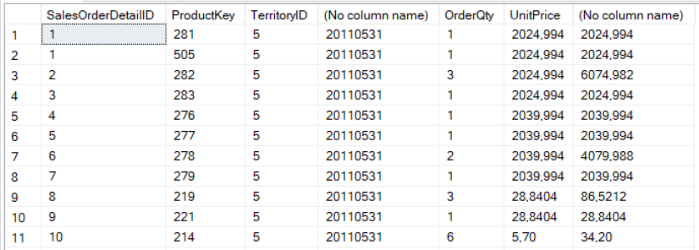

* + To see this more detailed, execute the following query in the DWH

SELECT d.SalesOrderDetailID, p.ProductKey, h.TerritoryID, CAST(FORMAT(h.OrderDate,'yyyyMMdd') as int), d.OrderQty, d.UnitPrice,

d.OrderQty * d.UnitPrice

FROM AdventureWorks2019.Sales.SalesOrderHeader h join

AdventureWorks2019.Sales.SalesOrderDetail d on h.SalesOrderID = d.SalesOrderID

join DimProduct p on d.ProductID = p.ProductID

**WHERE p.productkey = 281 or p.ProductKey = 505**

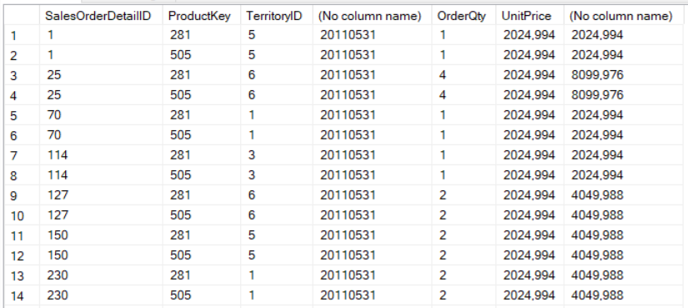

* + Of course, we don't want to add the same SalesOrder twice in the DWH. This is solved by adding a WHERE clause

SELECT d.SalesOrderDetailID, p.ProductKey, h.TerritoryID, CAST(FORMAT(h.OrderDate,'yyyyMMdd') as int), d.OrderQty, d.UnitPrice,

d.OrderQty * d.UnitPrice

FROM AdventureWorks2019.Sales.SalesOrderHeader h join

AdventureWorks2019.Sales.SalesOrderDetail d on h.SalesOrderID = d.SalesOrderID

join DimProduct p on d.ProductID = p.ProductID

**/* Slowly Changing Dimension DimProduct */**

**WHERE h.OrderDate >= p.start and (p.[end] is null or h.orderdate <= p.[end])**

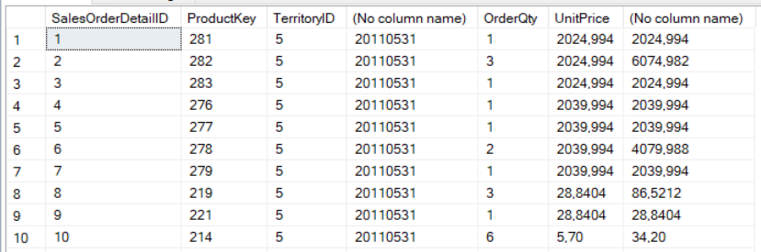

* + To see this more detailed, execute the following query in the DWH

SELECT d.SalesOrderDetailID, p.ProductKey, h.TerritoryID, CAST(FORMAT(h.OrderDate,'yyyyMMdd') as int), d.OrderQty, d.UnitPrice,

d.OrderQty * d.UnitPrice

from AdventureWorks2019.Sales.SalesOrderHeader h join

AdventureWorks2019.Sales.SalesOrderDetail d on h.SalesOrderID = d.SalesOrderID

join DimProduct p on d.ProductID = p.ProductID

**WHERE (p.productkey = 281 or p.ProductKey = 505) AND**

**/* Slowly Changing Dimension DimProduct */**

h.OrderDate >= p.start and (p.[end] is null or h.orderdate <= p.[end])

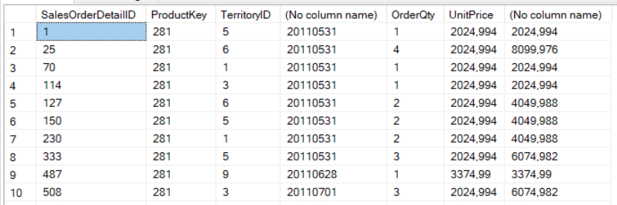

* + We add the second part of the WHERE clause because we only need to add **new** lines in consecutive runs of the statement.   
    The ISNULL function is necessary for the first run (when FactSales is empty) because SELECT MAX() returns NULL on an empty table

SELECT d.SalesOrderDetailID, p.ProductKey, h.TerritoryID, CAST(FORMAT(h.OrderDate,'yyyyMMdd') as int), d.OrderQty, d.UnitPrice,

d.OrderQty * d.UnitPrice

from AdventureWorks2019.Sales.SalesOrderHeader h join

AdventureWorks2019.Sales.SalesOrderDetail d on h.SalesOrderID = d.SalesOrderID

join DimProduct p on d.ProductID = p.ProductID

WHERE

/* Slowly Changing Dimension dimproduct */

h.OrderDate >= p.start and (p.[end] is null or h.orderdate <= p.[end])

AND

**/* only add new lines + make sure it runs from an empty FactSales table */**

**d.SalesOrderDetailID > (SELECT ISNULL(MAX(SalesOrderLineNumber),0) from FactSales)**

* + The previous statement is used fo **fill** FactSales => add INSERT at the top of the statement
  + Execute the following statement in the DWH to see that FactSales get's the right content
  + Empty FactSales afterwards: DELETE FROM FactSales

**INSERT INTO FactSales(SalesOrderLineNumber, ProductKey, SalesTerritoryKey,**

**OrderDateKey, OrderQuantity, UnitPrice, ExtendedAmount)**

SELECT d.SalesOrderDetailID, p.ProductKey, h.TerritoryID, CAST(FORMAT(h.OrderDate,'yyyyMMdd') as int), d.OrderQty, d.UnitPrice,

d.OrderQty * d.UnitPrice

from AdventureWorks2019.Sales.SalesOrderHeader h join

AdventureWorks2019.Sales.SalesOrderDetail d on h.SalesOrderID = d.SalesOrderID

join DimProduct p on d.ProductID = p.ProductID

WHERE

/* Slowly Changing Dimension dimproduct */

h.OrderDate >= p.start and (p.[end] is null or h.orderdate <= p.[end])

AND

/* only add new lines + make sure it runs from an empty FactSales table */

d.SalesOrderDetailID > (SELECT ISNULL(MAX(SalesOrderLineNumber),0) from FactSales)

1. In Visual Studio 2017 SSDT, drag and drop 'Execute SQL Task' from the SSIS Toolbox (at the left) to the Control Flow area.
2. Connect to the previous tasks

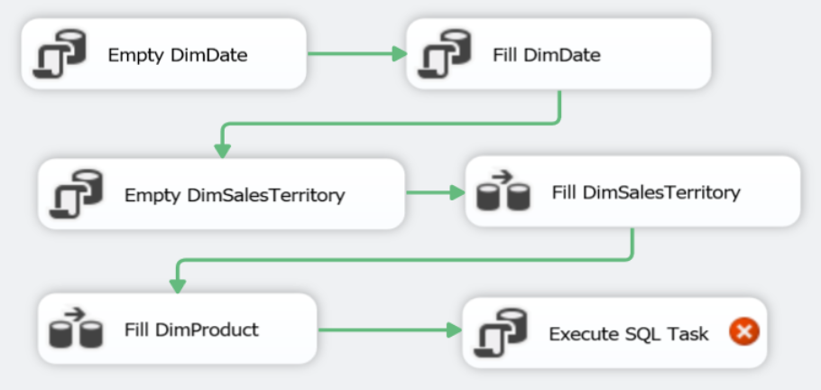

1. Right click on Execute SQL Task and choose Edit… to configure the Execute SQL Task

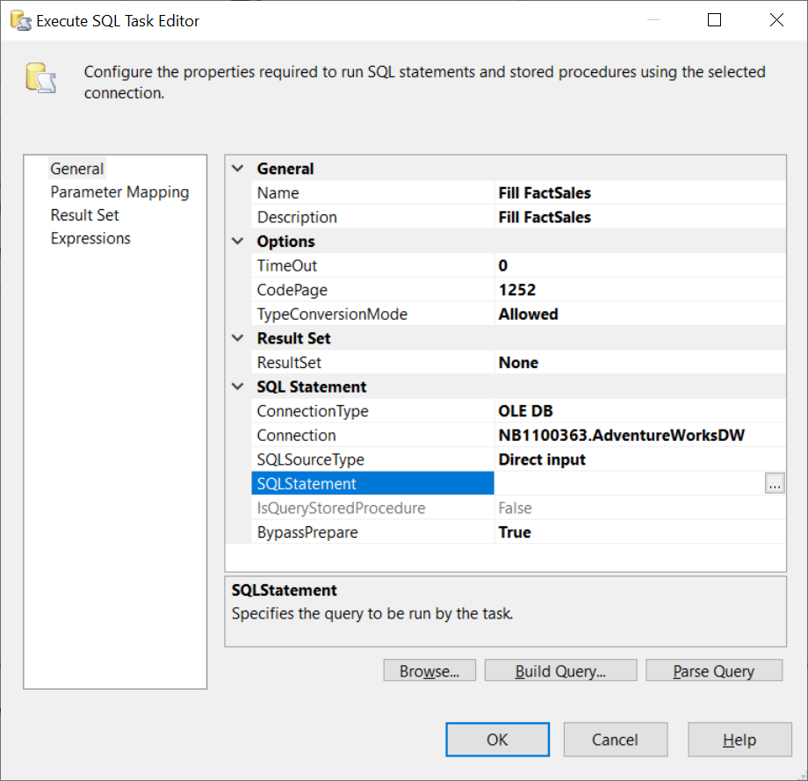

1. Click on the … next tot SQL Statement and copy paste the entire, previous SQL statement

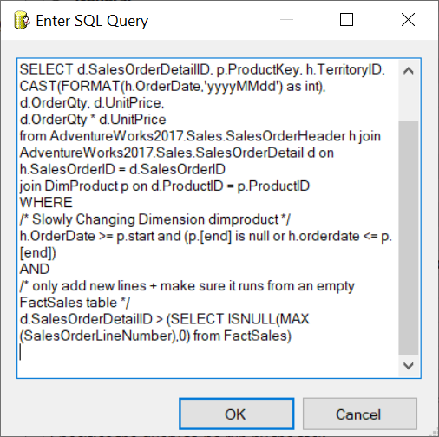

1. Click OK x 2
2. Try to run the provisional pipeline.

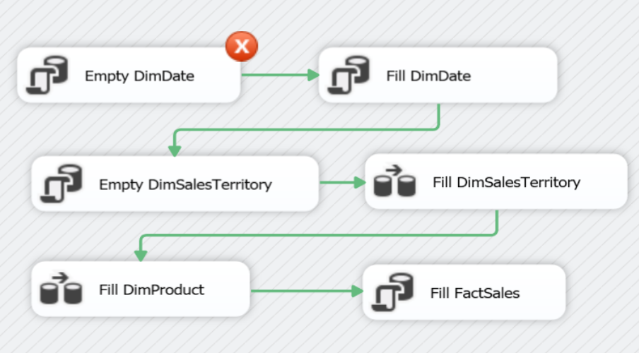

1. We get an error message because we are trying to delete DimDate and DimSalesTerritory while there are foreign key constraints between those tables and FactSales.

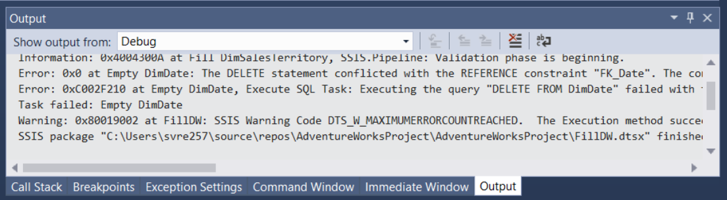

1. One way to cope with this is to temporarily disable the constraints at the start of the fill operation and enable them again at the end.
2. Add two Execute SQL Tasks and connect to the previous tasks.

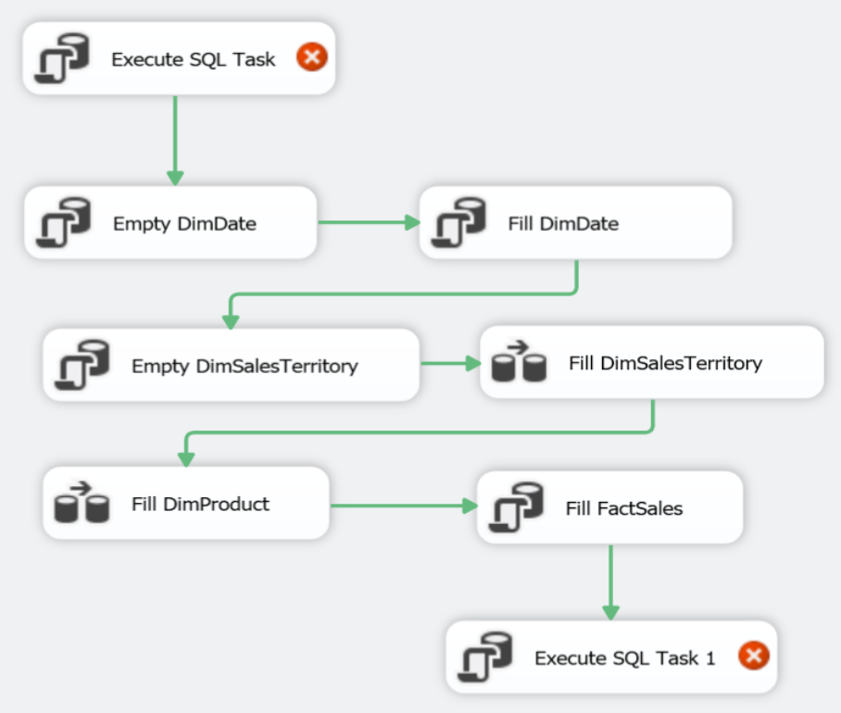

1. Rightclick on both tasks and choose Edit… to configure the tasks
   * At the start of the pipeline: Disable Foreign Keys  
     SQL command = ALTER TABLE FactSales NOCHECK CONSTRAINT ALL
   * At the end of the pipeline: Enable Foreign Keys  
     SQL command = ALTER TABLE FactSales WITH CHECK CHECK CONSTRAINT ALL; (2 times CHECK!)

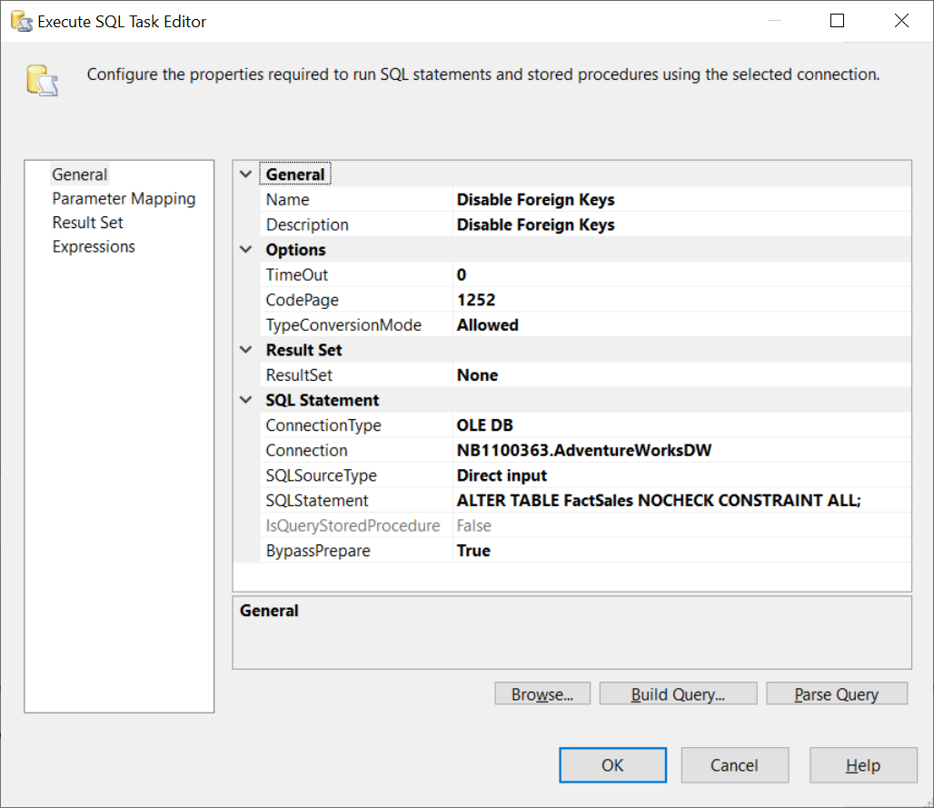

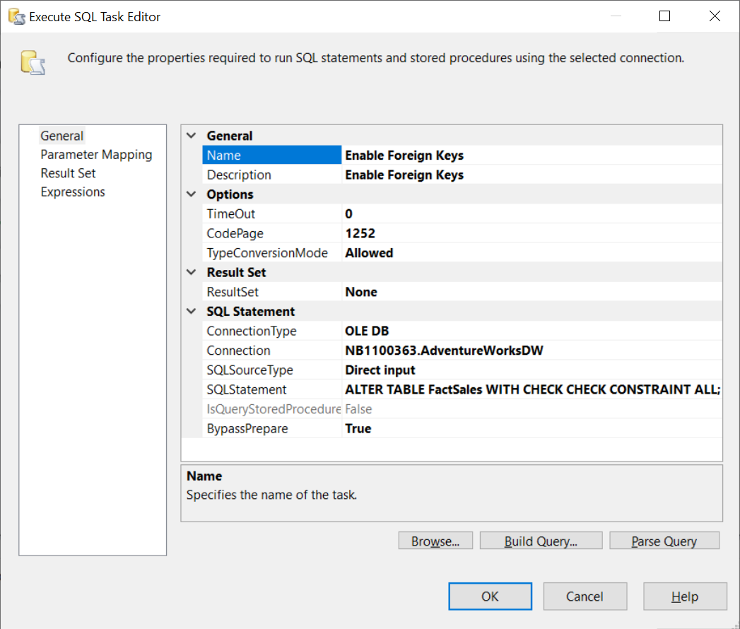

1. Run the final pipeline. Make sure that FactSales is empty at the beginning (DELETE FROM FactSales)

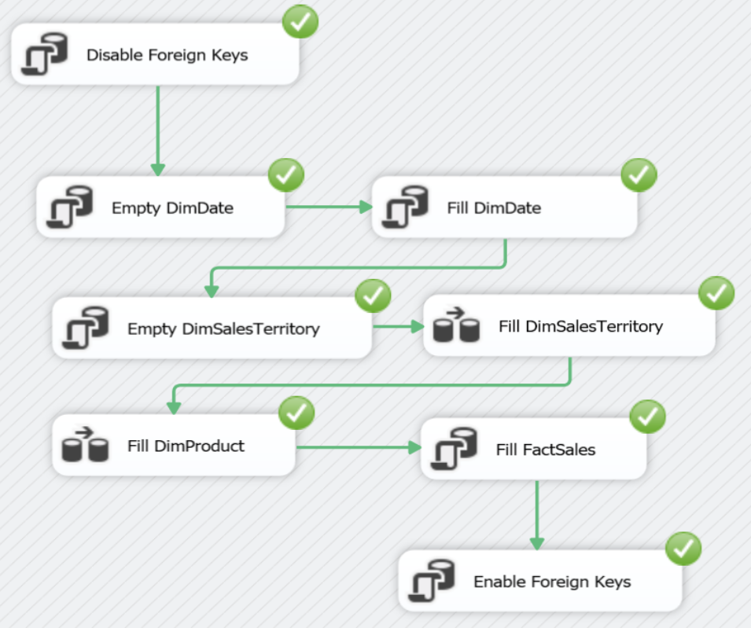

1. As a final test we can add a sales line for an updated product in the operational system and check if the corresponding FactSales line in the datawarehouse will be linked to the correct ProductKey in DimProduct.
2. First we have to create a new record in SalesOrderHeader in the OLTP database AdventureWorks. Execute the following command in the OLTP database.  
   It can be a good idea to first execute the SELECT commands to better understand the entire command,

INSERT INTO [Sales].[SalesOrderHeader]

([RevisionNumber], [OrderDate], [DueDate], [ShipDate], [Status], [OnlineOrderFlag], [PurchaseOrderNumber], [AccountNumber], [CustomerID], [SalesPersonID], [TerritoryID], [BillToAddressID], [ShipToAddressID], [ShipMethodID], [CreditCardID], [CreditCardApprovalCode], [CurrencyRateID], [SubTotal], [TaxAmt], [Freight], [Comment], [rowguid], [ModifiedDate])

SELECT s.RevisionNumber, GETDATE(), GETDATE(), GETDATE(),s.Status,

s.OnlineOrderFlag,s.PurchaseOrderNumber,s.AccountNumber,s.CustomerID,

s.SalesPersonID,s.TerritoryID,s.BillToAddressID,s.ShipToAddressID,

s.ShipMethodID,s.CreditCardID,s.CreditCardApprovalCode,s.CurrencyRateID,

s.SubTotal,s.TaxAmt,s.Freight,s.Comment, NEWID(), GETDATE()

FROM sales.salesorderheader s

WHERE salesorderid = (SELECT MAX(salesorderid) FROM sales.salesorderheader);

1. Now check for the key value to use in the following step to insert a new record into SalesOrderDetail  
   SELECT MAX(salesorderid) FROM sales.salesorderheader 🡪 75126
2. Next we have to create a new record in SalesOrderDetail in the OLTP database AdventureWorks. Execute the following command in the OLTP database.

INSERT INTO [Sales].[SalesOrderDetail]([SalesOrderID], [CarrierTrackingNumber], [OrderQty], [ProductID], [SpecialOfferID], [UnitPrice], [UnitPriceDiscount], [rowguid], [ModifiedDate])

VALUES (75124,null,4,776,1,10,0,NEWID(),GETDATE());

1. Now rerun the package
2. Check DimProduct  
   SELECT * FROM dimproduct WHERE productid = 776;

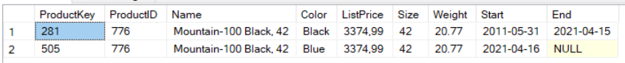

1. Check FactSales  
   SELECT TOP 1 * FROM factsales ORDER BY salesorderlinenumber DESC;



1. Correct!